Asymptotic Notation

# Source:

1. **Asymptotic Notation**

# Khan Academy: [Asymptotic Notation](https://www.khanacademy.org/computing/computer-science/algorithms#asymptotic-notation) learn here nice theory with examples practice here quiz’s

# 

## **Fig: - 1.1** Common Asymptotic Notations

Source: tutorials point

# Introduction to Logarithms:

# [logarithms](https://www.mathsisfun.com/algebra/logarithms.html) refer this very nice introduction about logs.

# 

## **Fig: - 1.2** Basic Log Example

Source: maths is fun

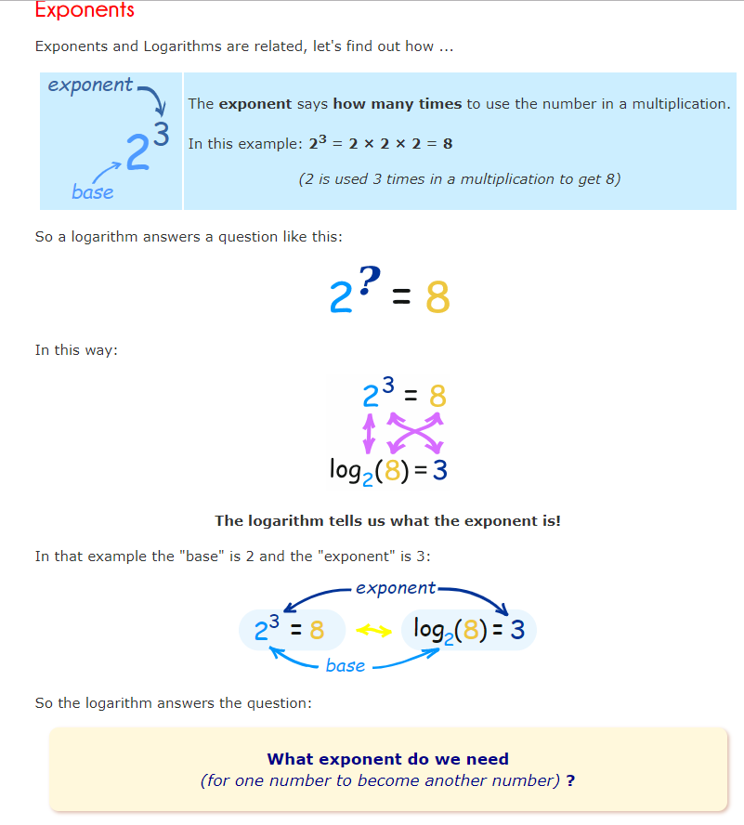

## **Fig: - 1.3** Exponent Log Example

Source: maths is fun

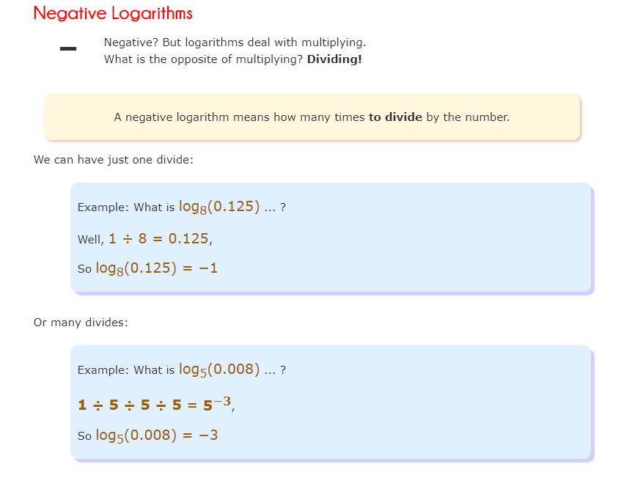

## **Fig: - 1.4** Negative Logs

Source: maths is fun

Quiz source **Khan Academy**

1. Question

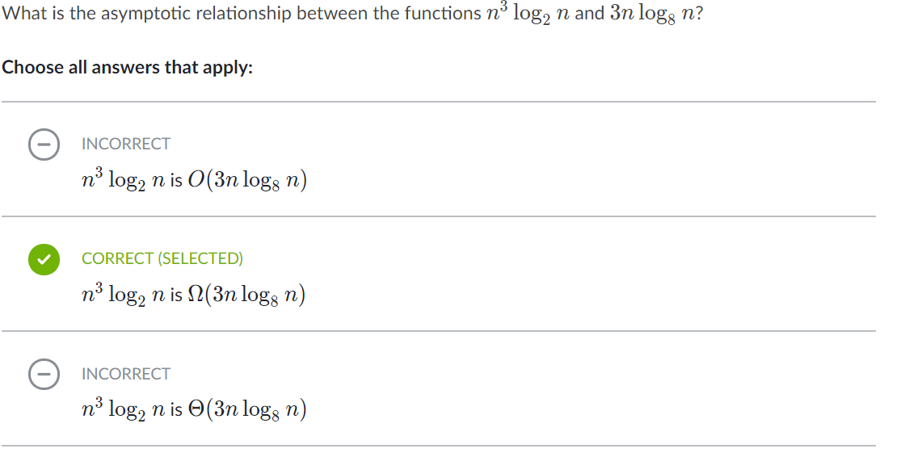

Explanation: -

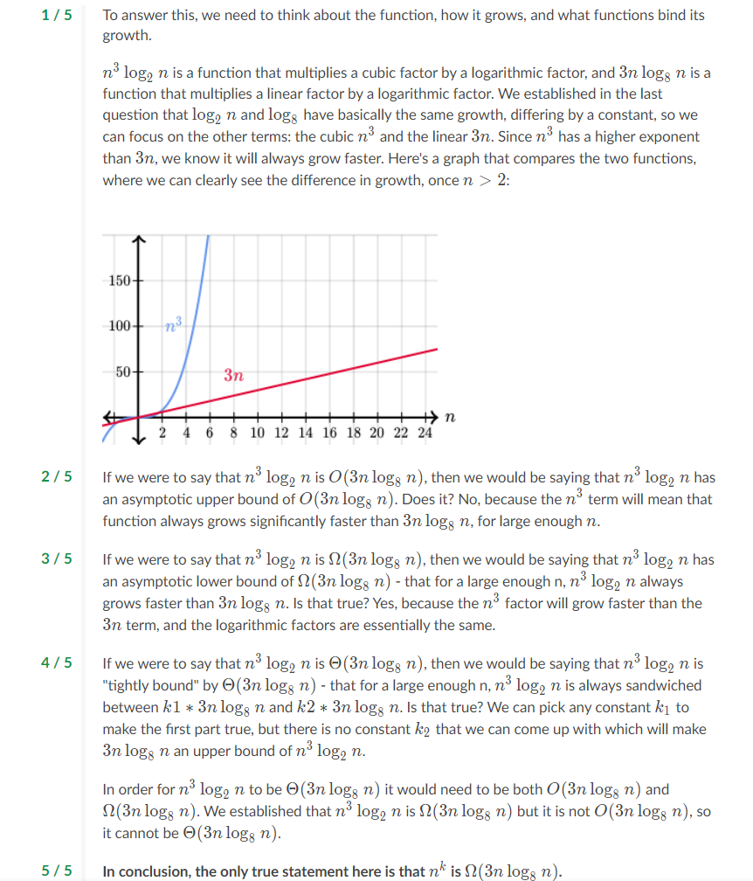

1. Question

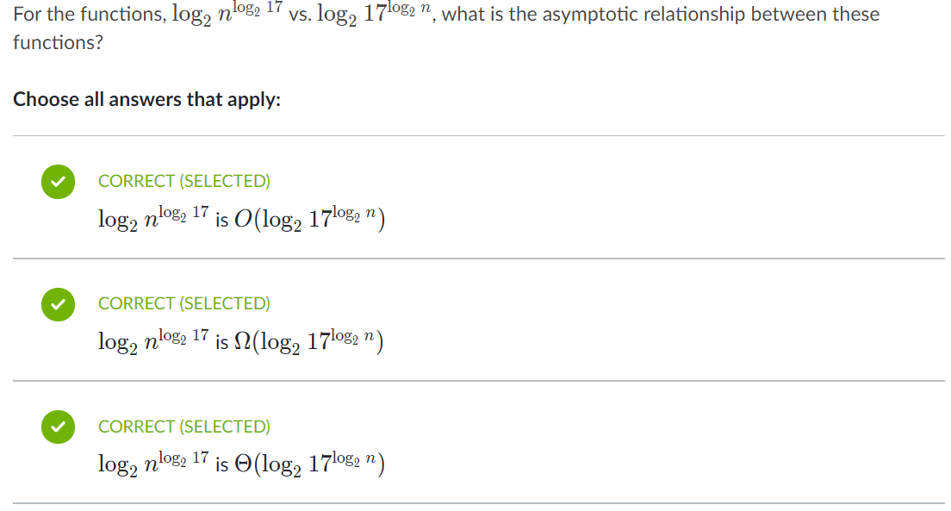

Explanation: -

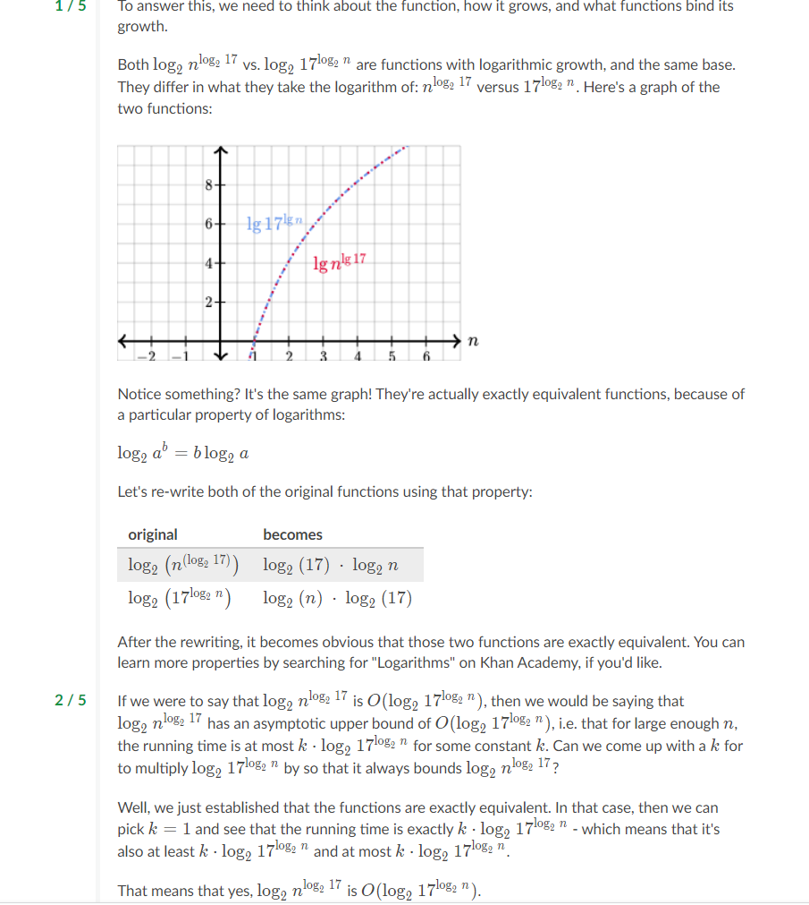

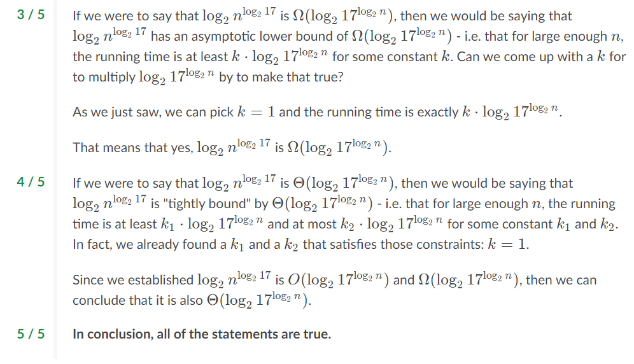

1. Question: -

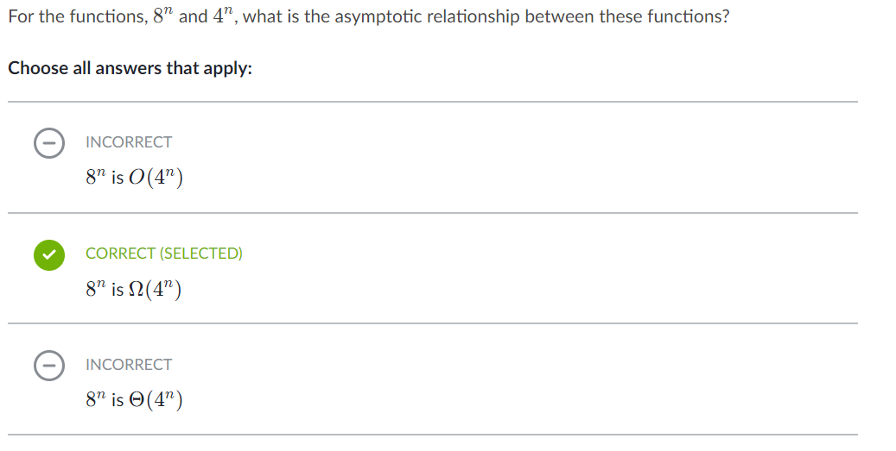

Explanation: -

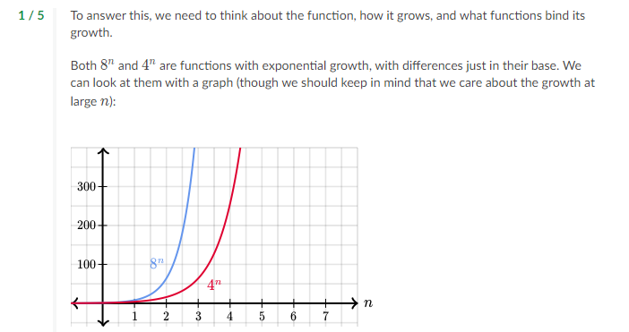

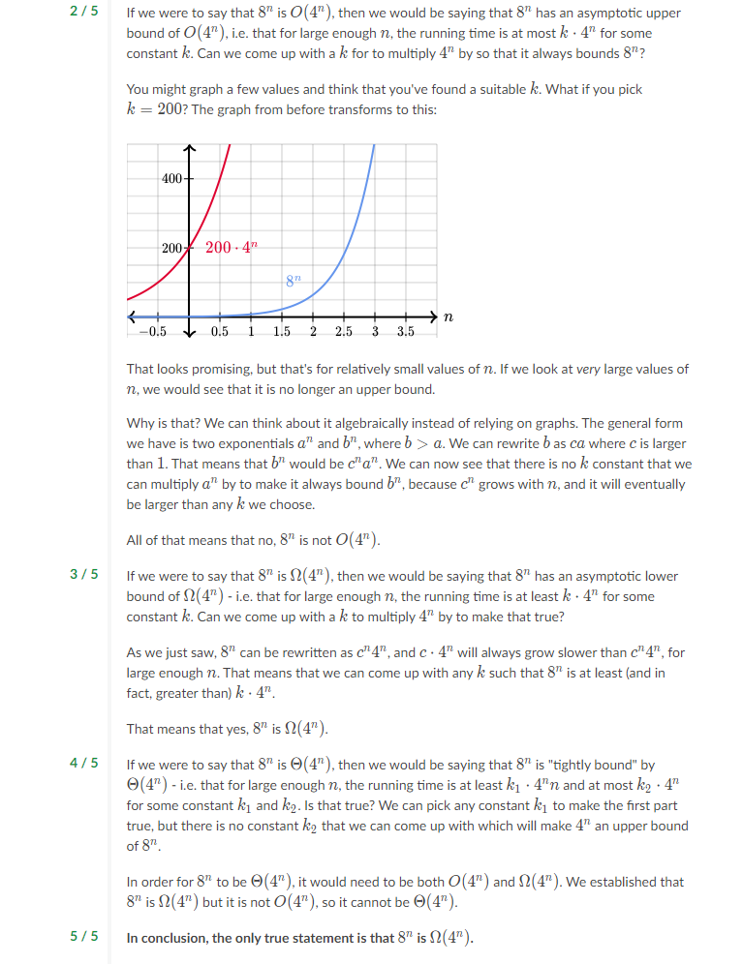

Algorithms from Abdul Bari channel.

1. Intro about course

# Priori Analysis and Posteriori Testing

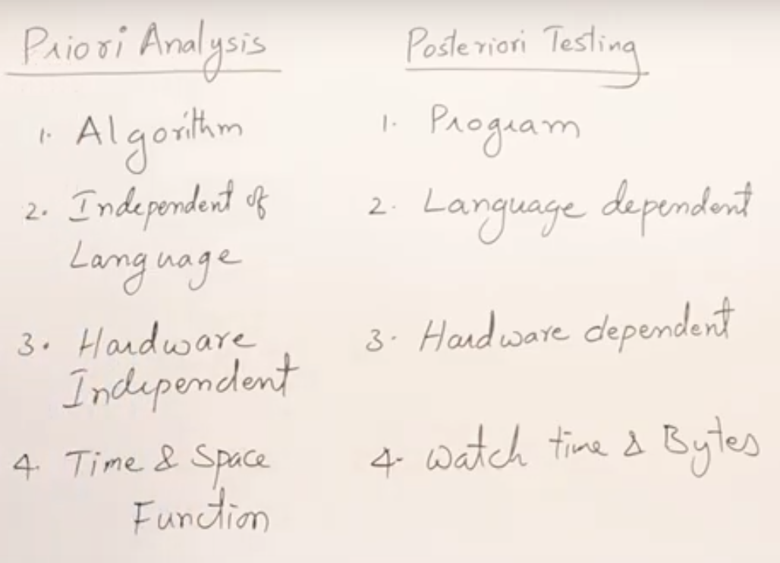

# 1.2 Characteristics of Algorithm

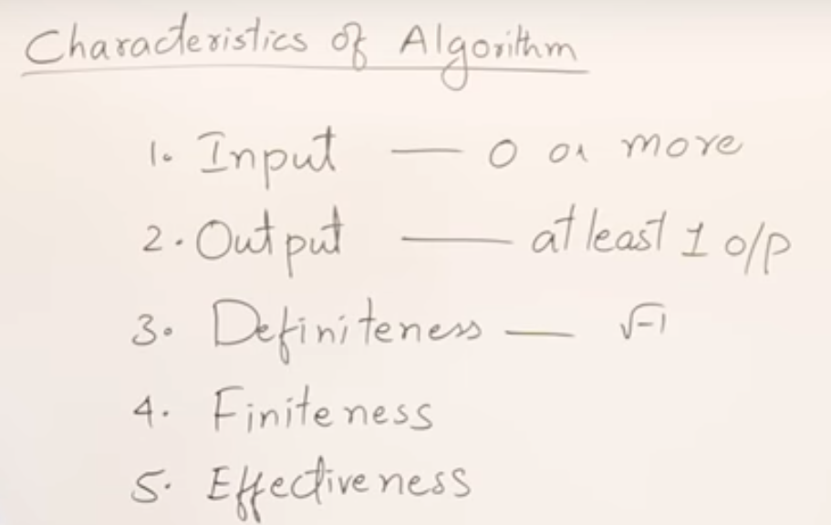

* 0 or more inputs it can have.
* Should have at least one output.
* It should not contain any indeterminate statements like √-1.
* Algorithm must have an end point.
* Don’t write unnecessary statements in it.

# 1.3 How Write and Analyse Algorithm

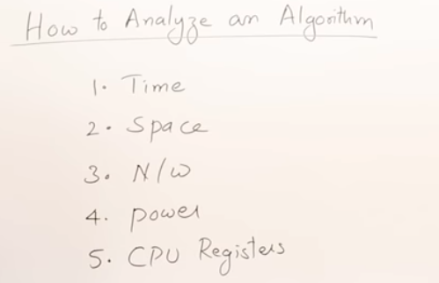

Chrematistics of algorithm.

* Time and space are common.
* If it is n/w-based app how much it is utilising.
* Power basically mobile based apps.
* If it is device driver CPU reg.

Basic time and space analysis

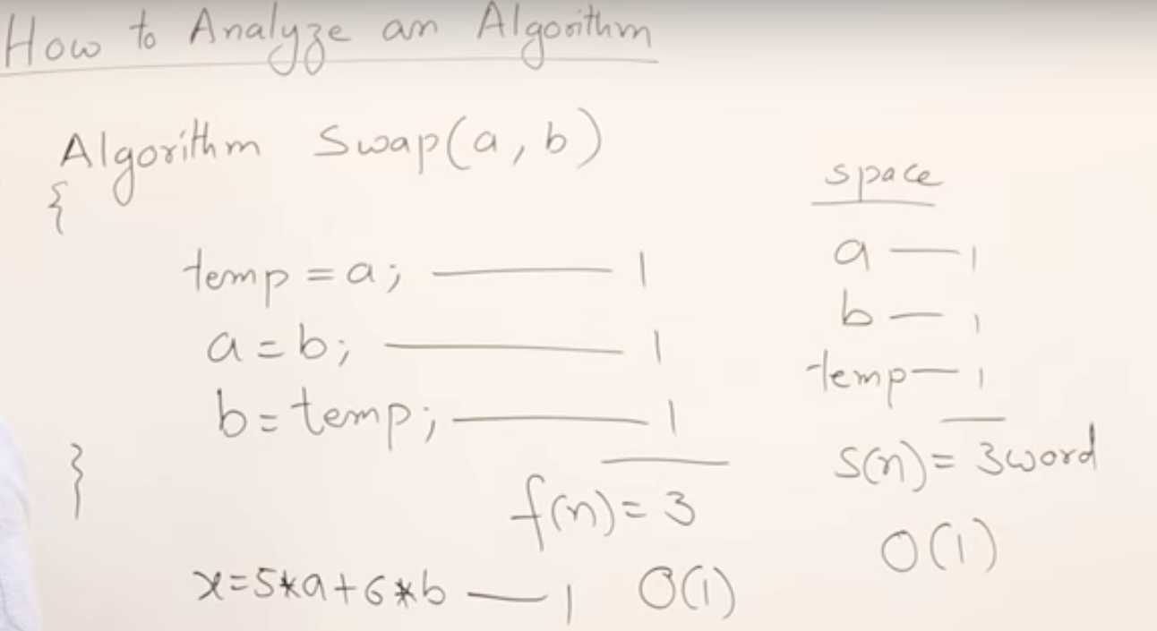

* All simple statements we will consider as 1 unit of time.
* Even if it’s a complex calculation.
* All variables are considered as 1 simple word because we don’t know about its size varies based on its type

# 1.4 Frequency Count Method

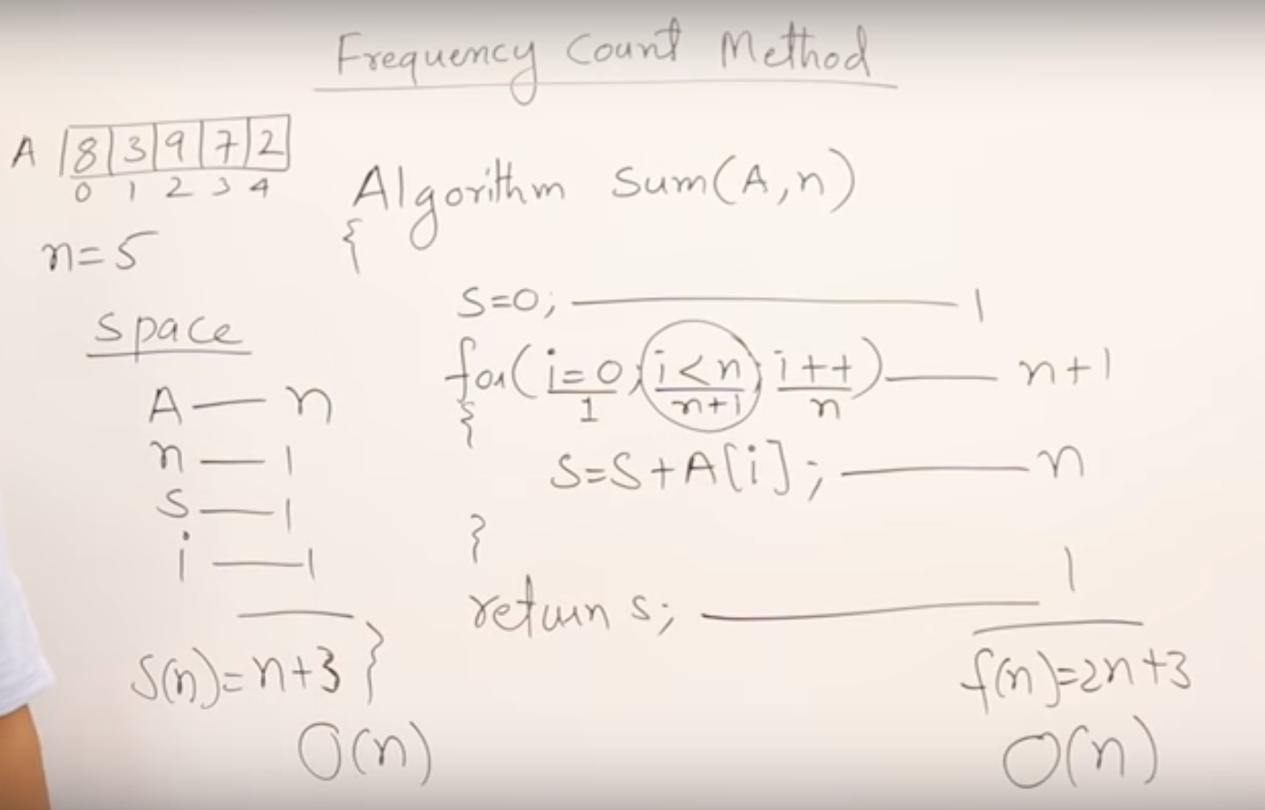

* Sum of an array elements analysis

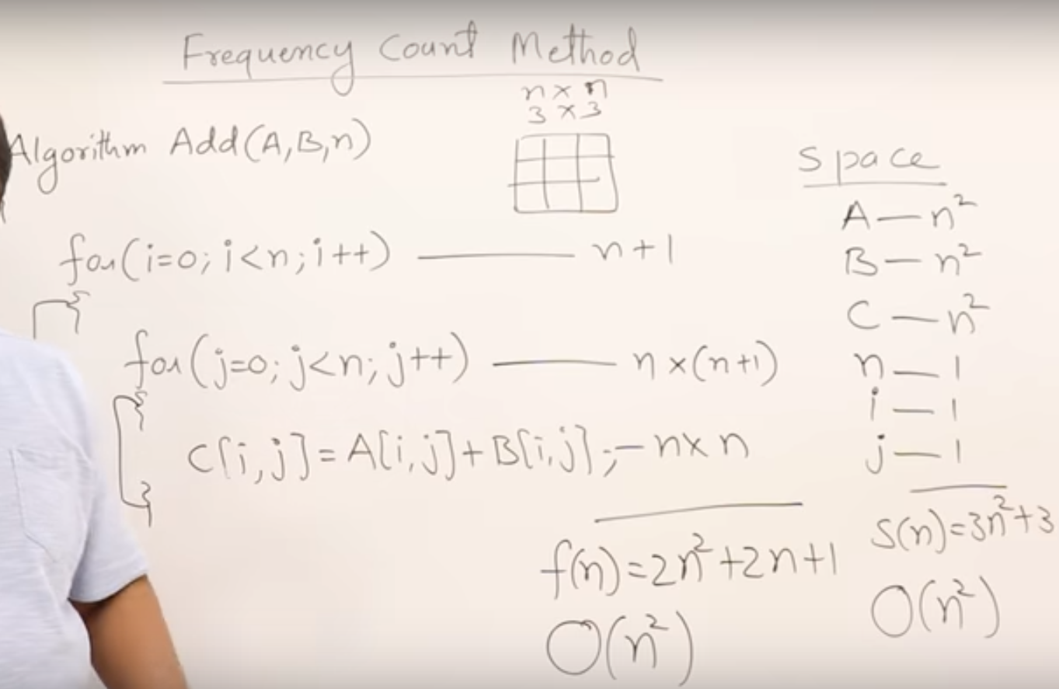

* Sum of two arrays elements analysis

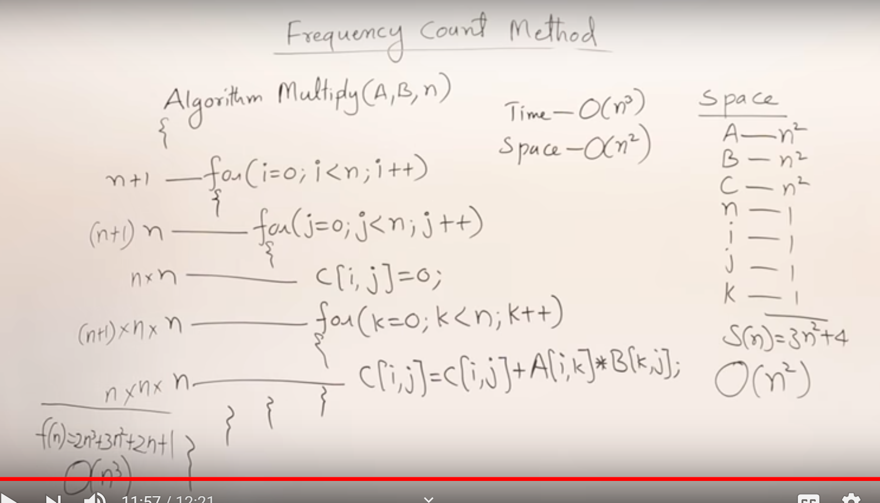

* Multiplication of two arrays elements analysis

1.5.1 Time Complexity #1

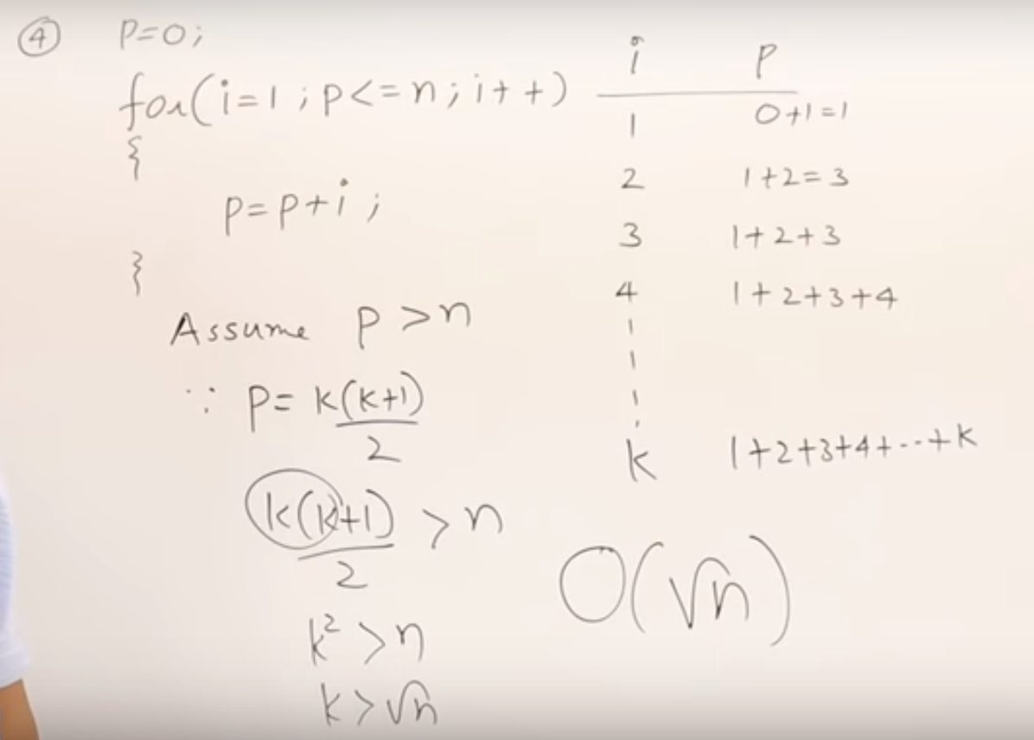

1.5.2 Time Complexity Example #2

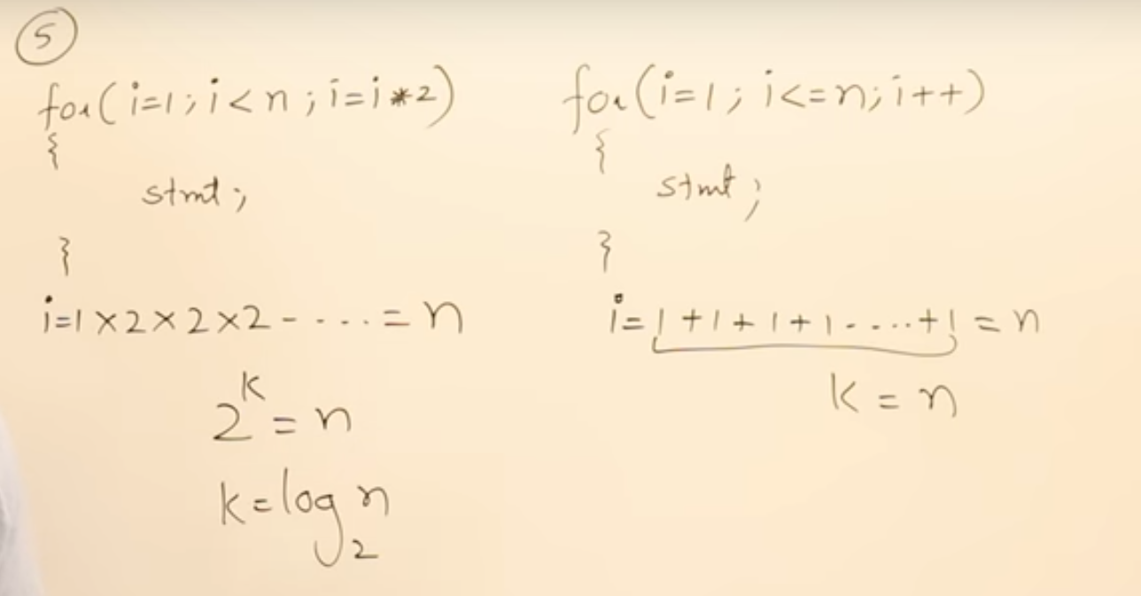

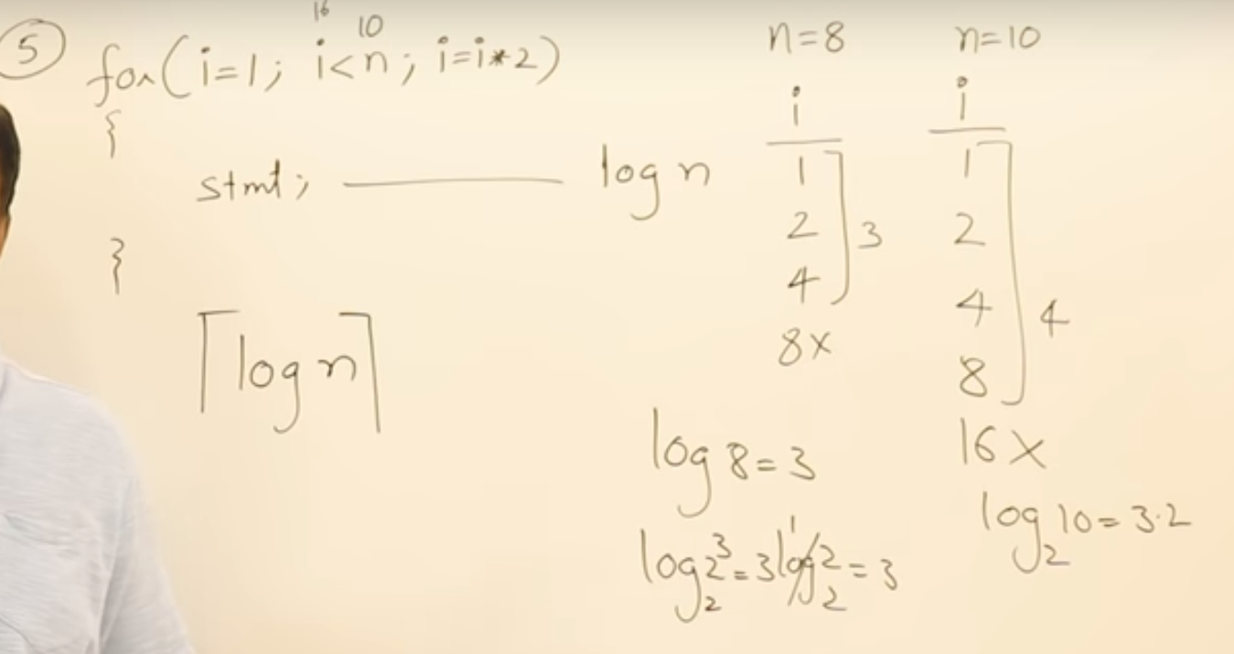

* Log value will be taken as a ceil value
* Observe the difference when n = 8 and n = 10

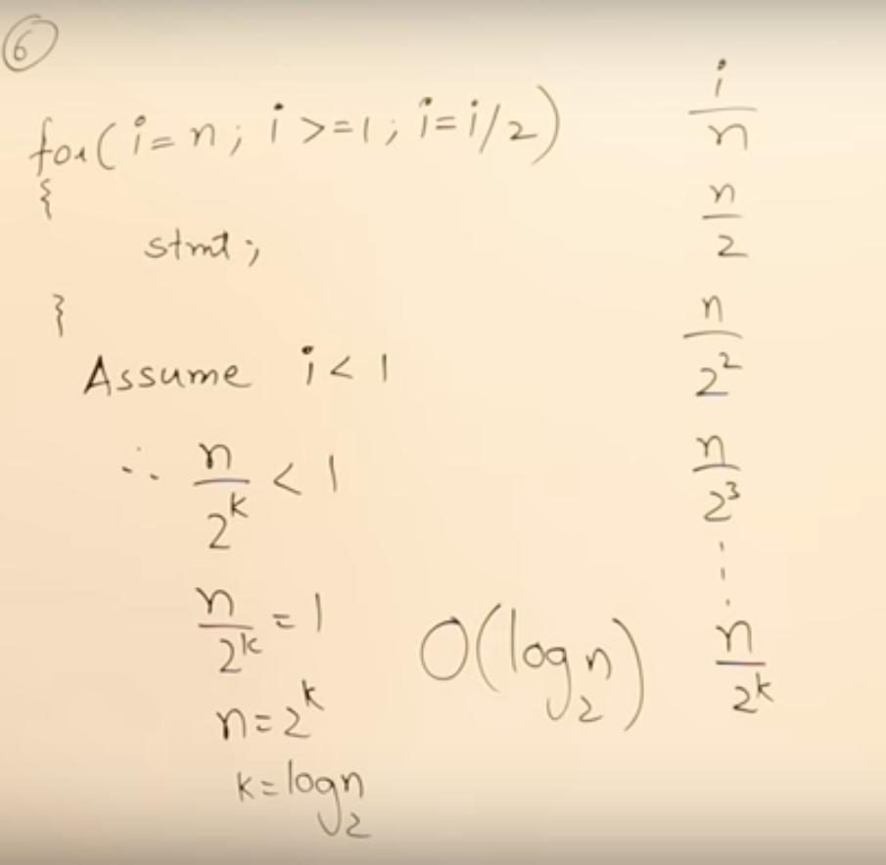

* Multiply or divide by 2 both are **log n**

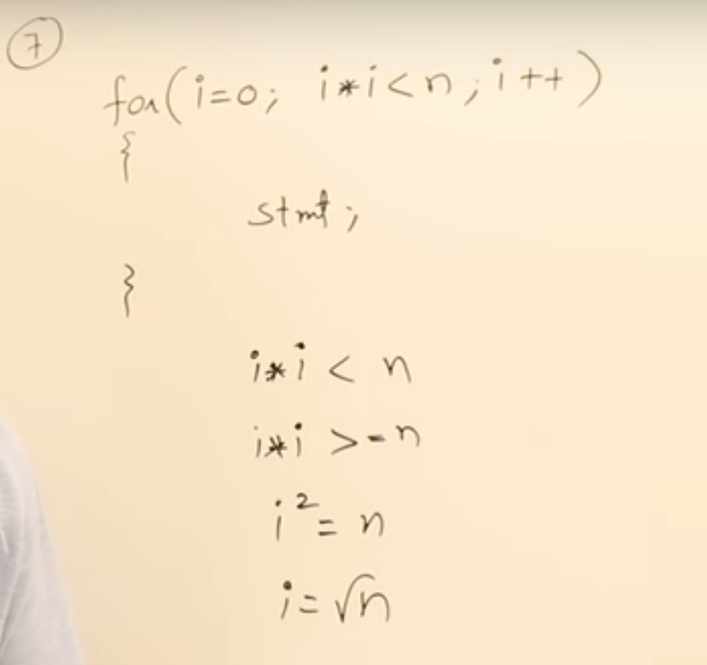

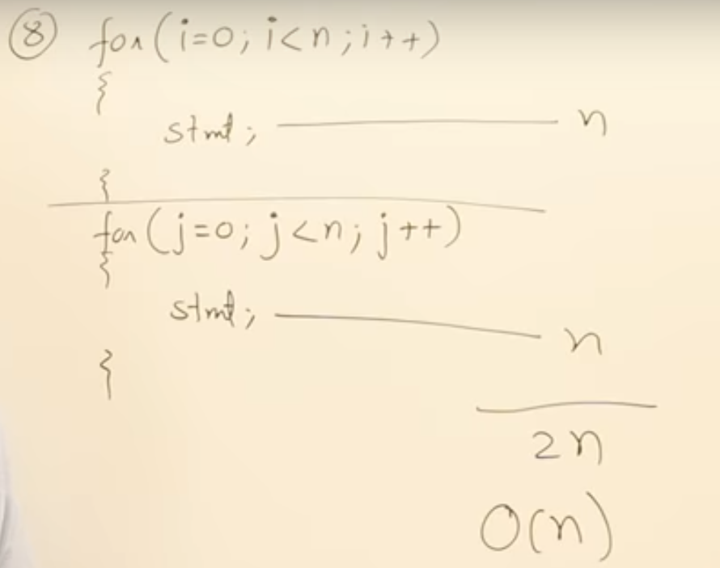

* Analysis of two independent loops

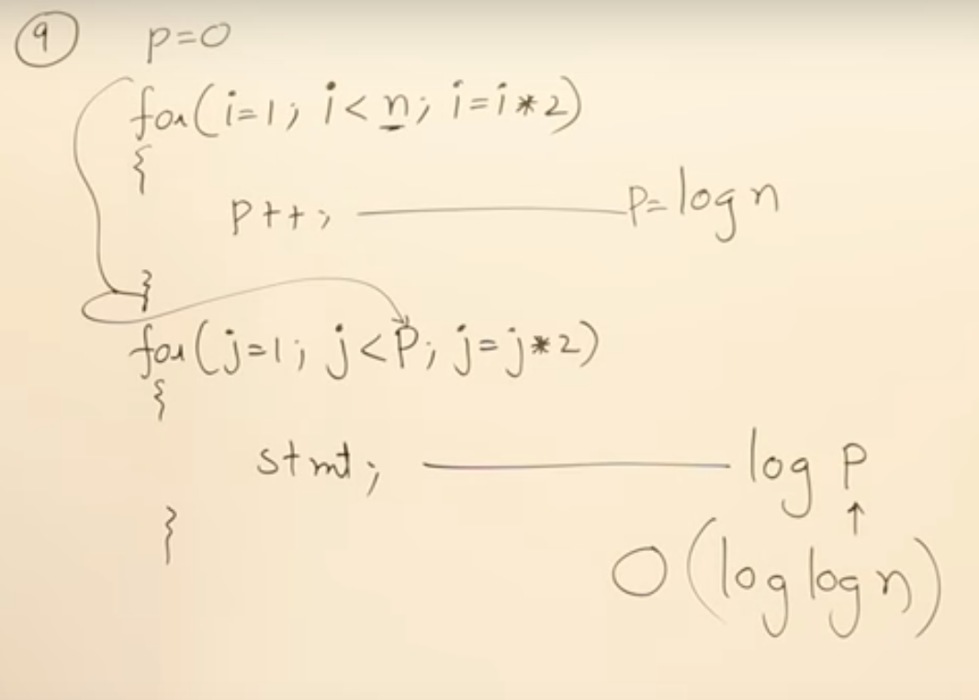

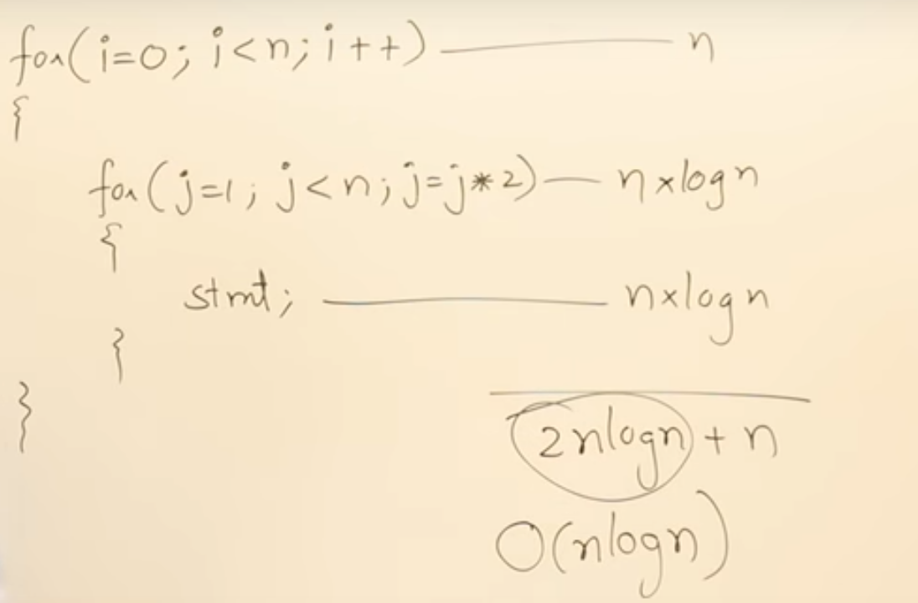

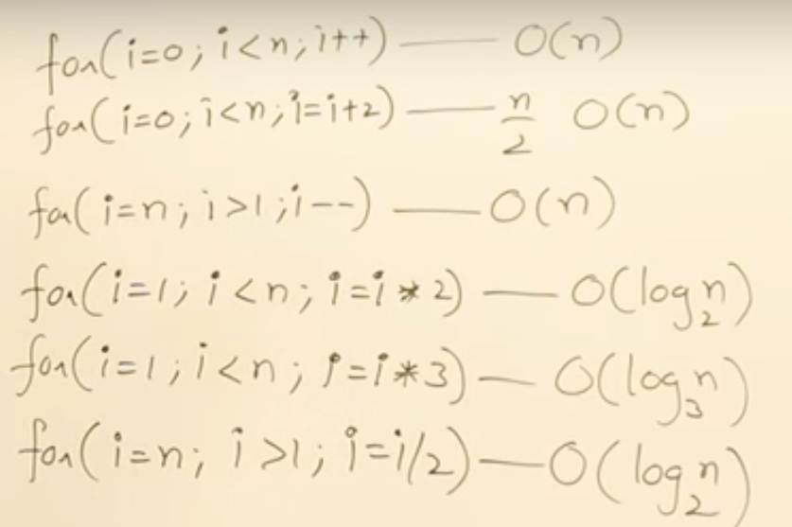

1.5.3 Time Complexity of While and if #3

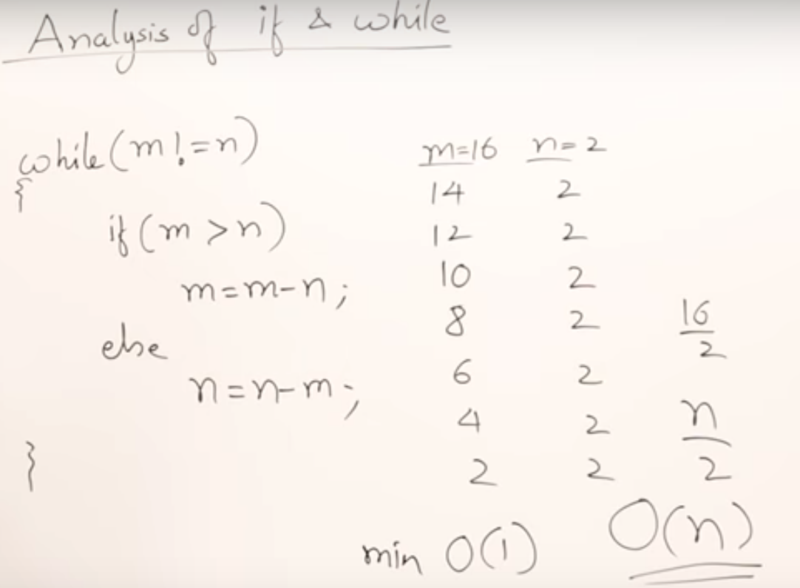

1.8.1 Asymptotic Notations Big Oh - Omega - Theta #1

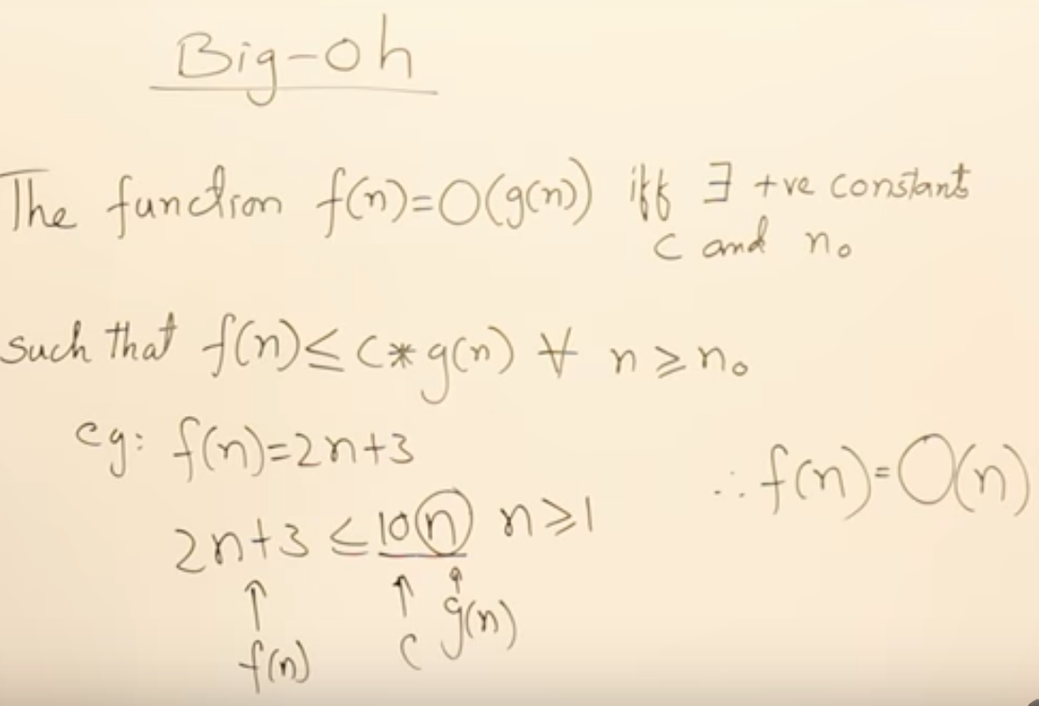

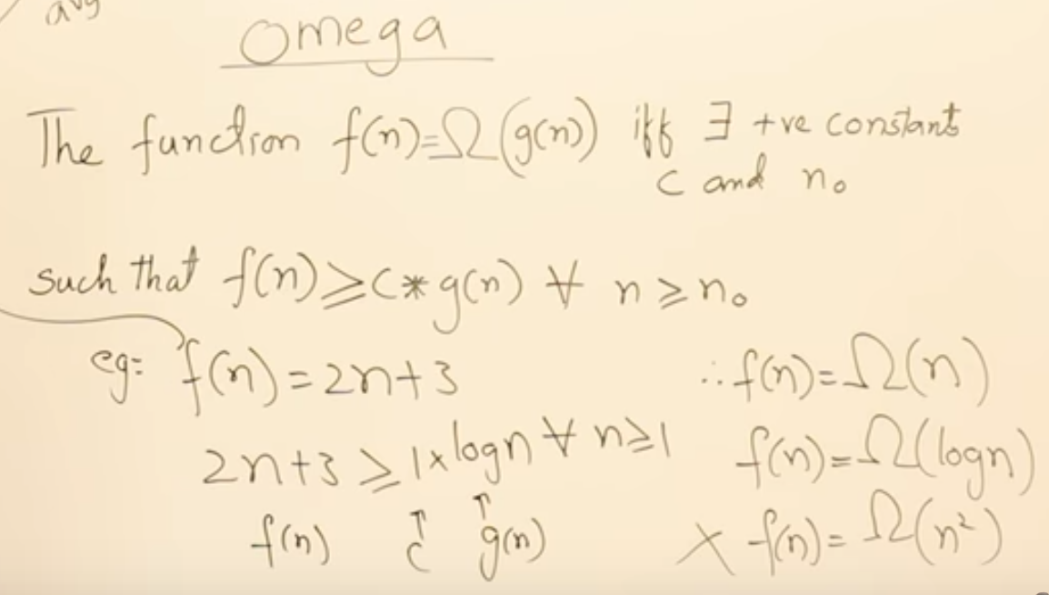

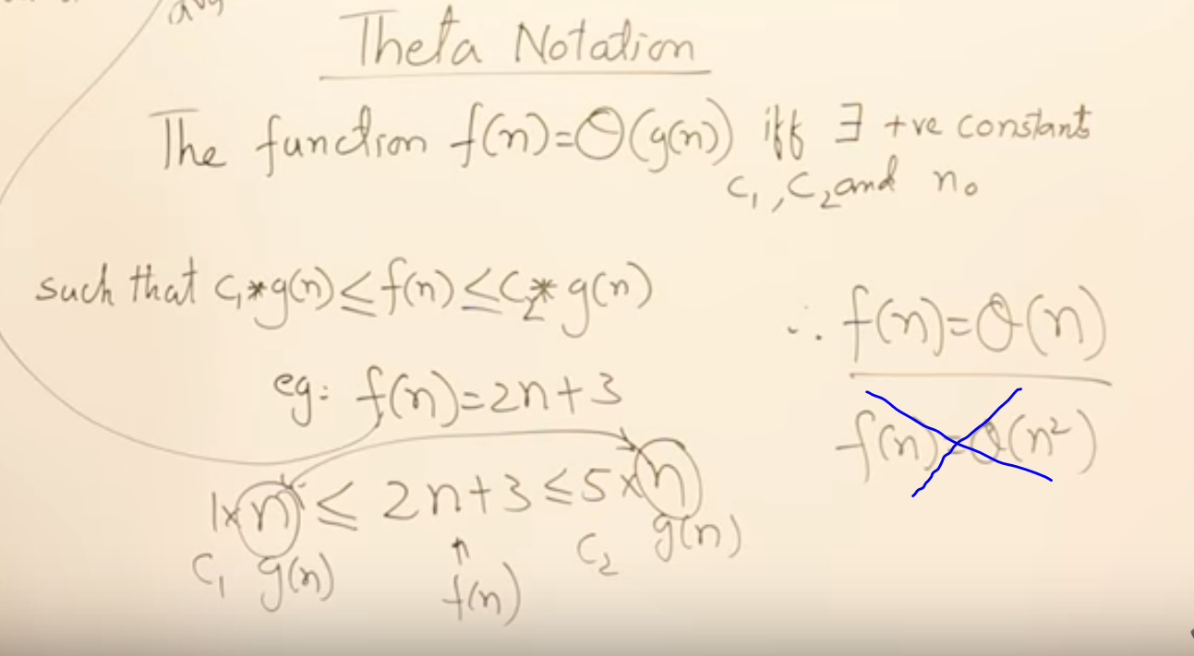

1.8.2 Asymptotic Notations - Big Oh - Omega - Theta #2

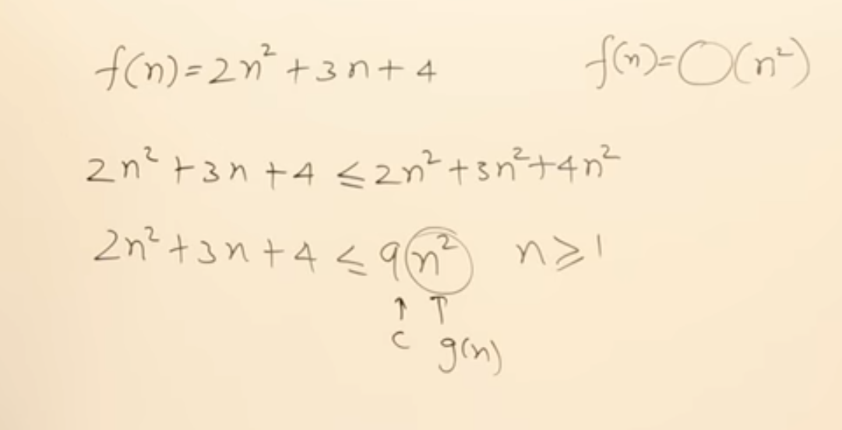

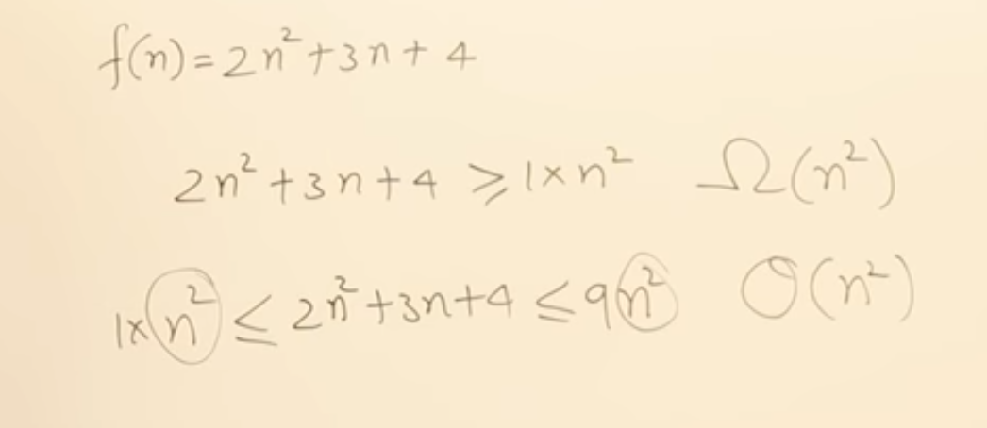

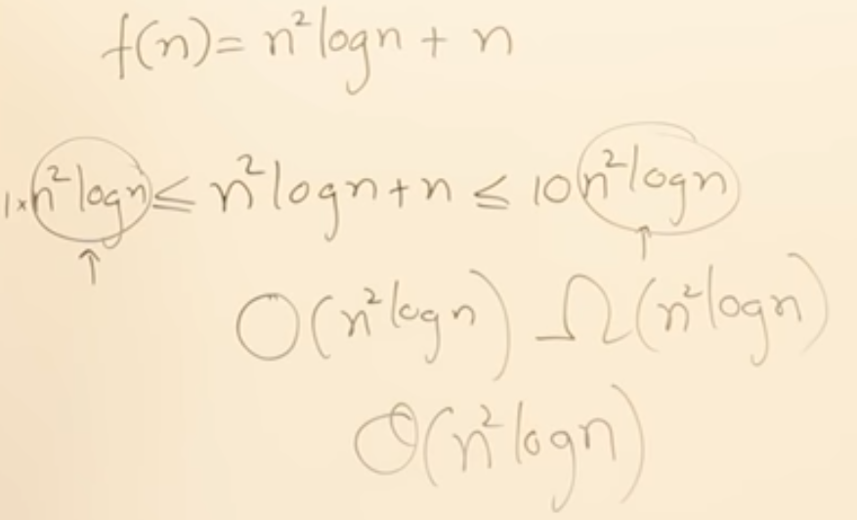

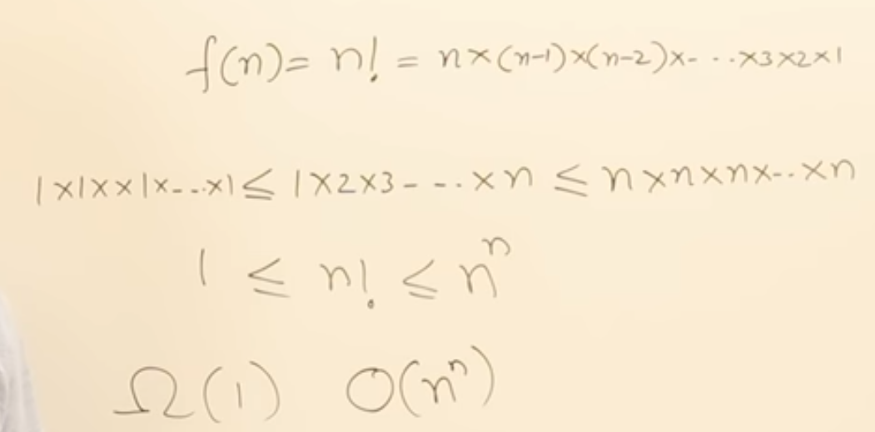

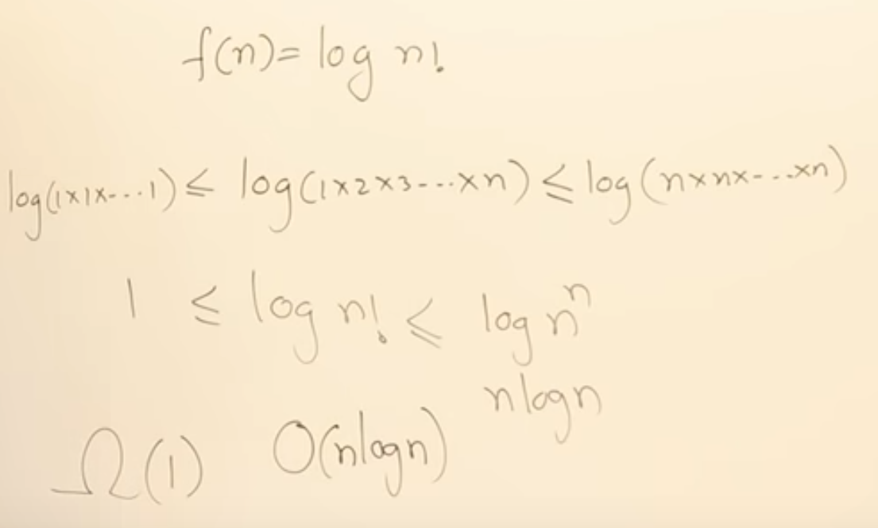

1.9 Properties of Asymptotic Notations

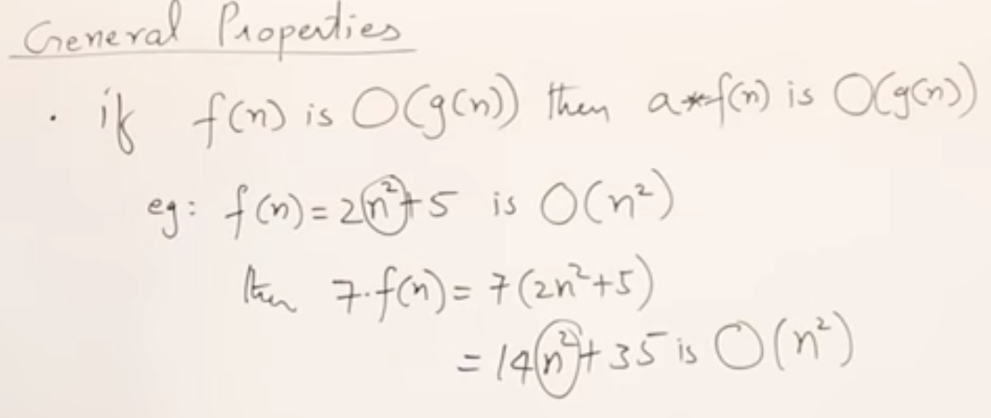

* Same property applied for all 3 notations

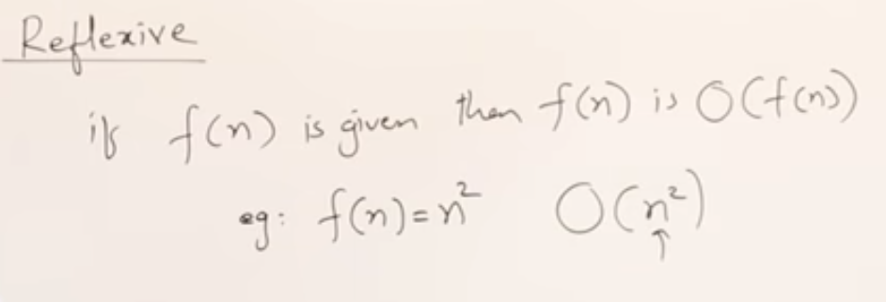

* A function itself upper bound/lower bound read about definitions of notations

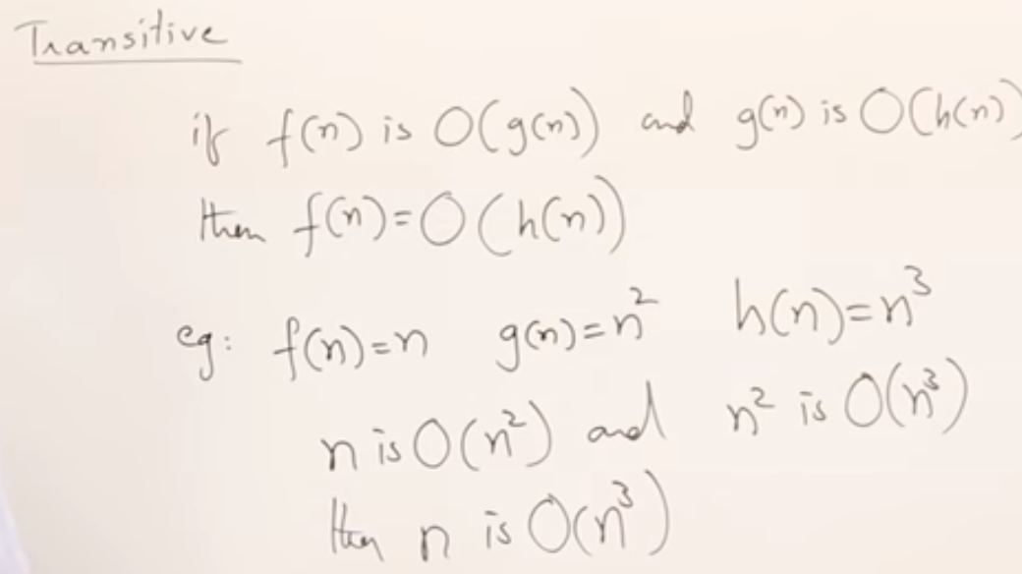

* Same property applied for all 3 notations

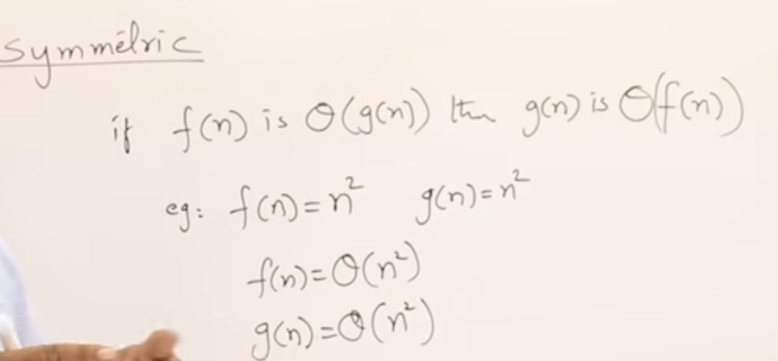

* this property applied for only theta notation

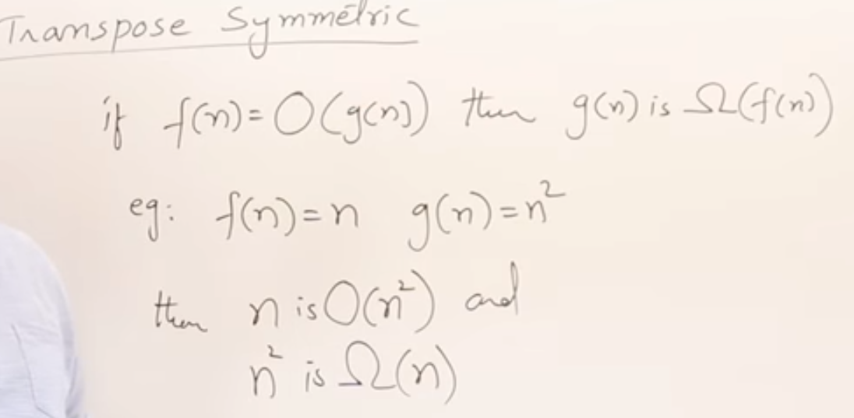

* this property applied for bigh O and theta notation
* Transpose symmetric Theta notion  
  if *f(n) =Ω (g(n)) then g(n) is O(f(n)).*

Examples

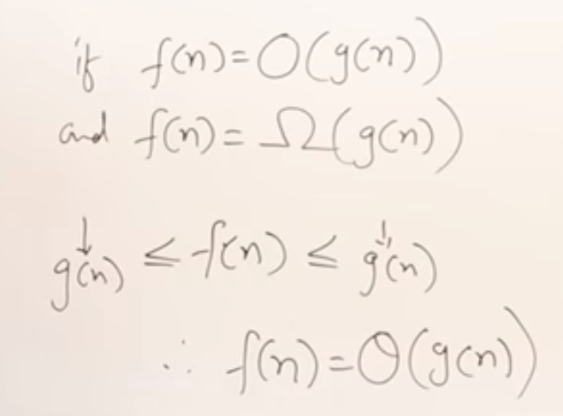

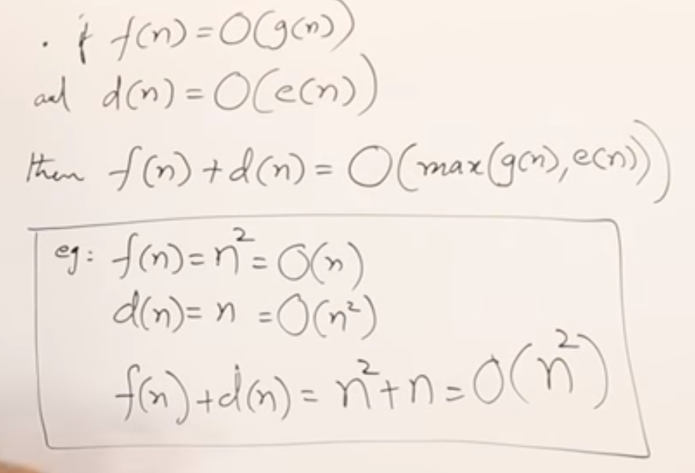

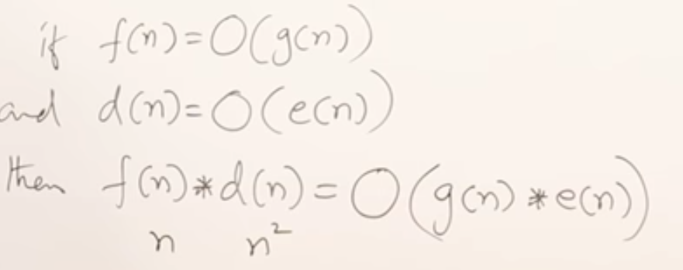

1.10.1 Comparison of Functions #1

How we can compare two functions to represent in asymptotic notations.

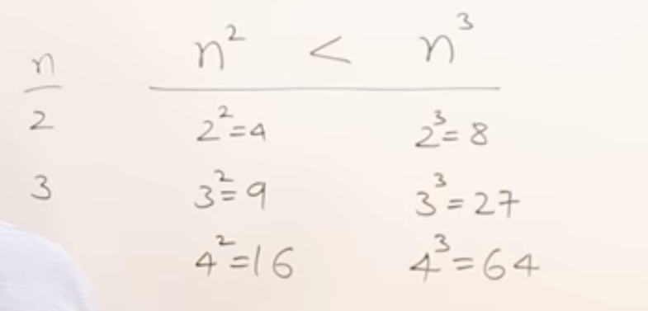

* Sample some values into function to know which function is greater or less

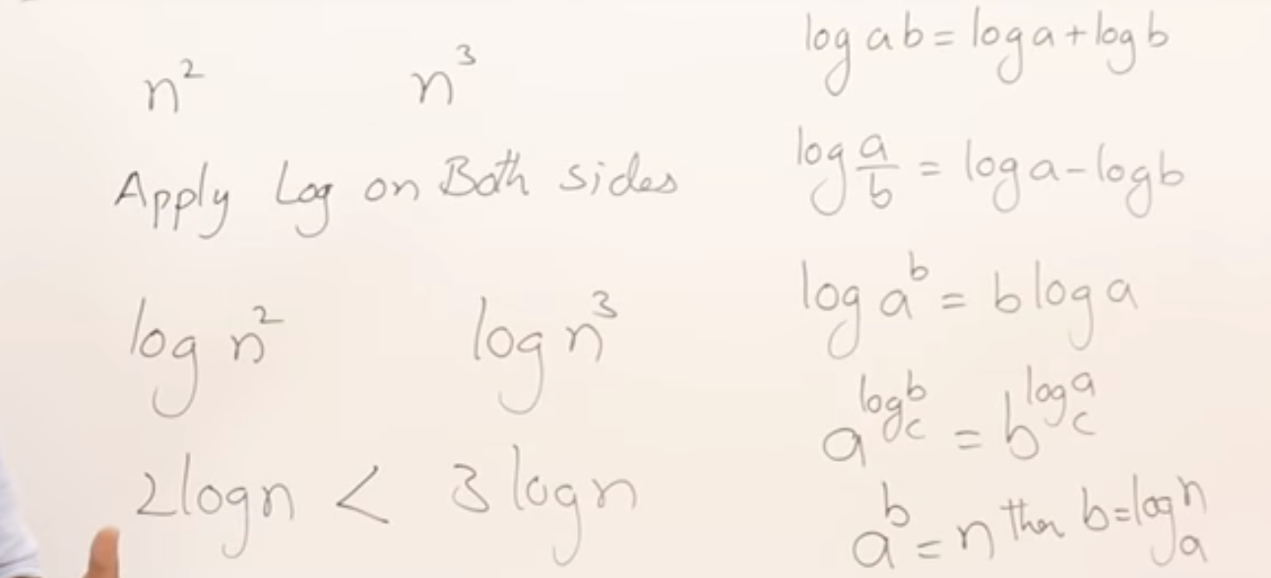

* Apply *log* on both sides

Example

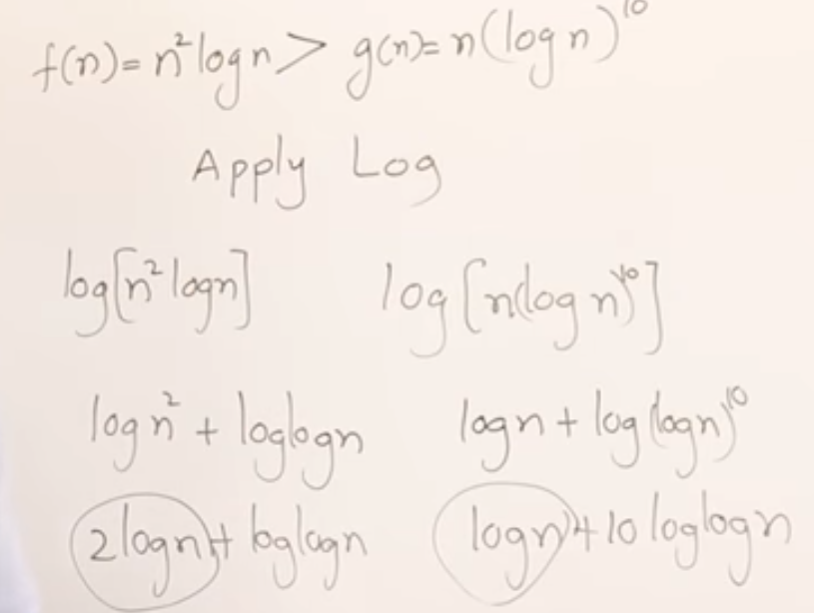

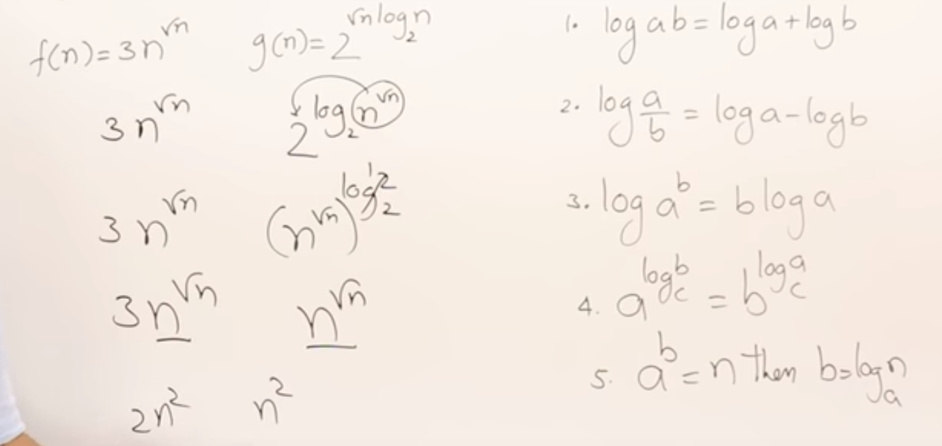

1.10.2 Comparison of Functions #2

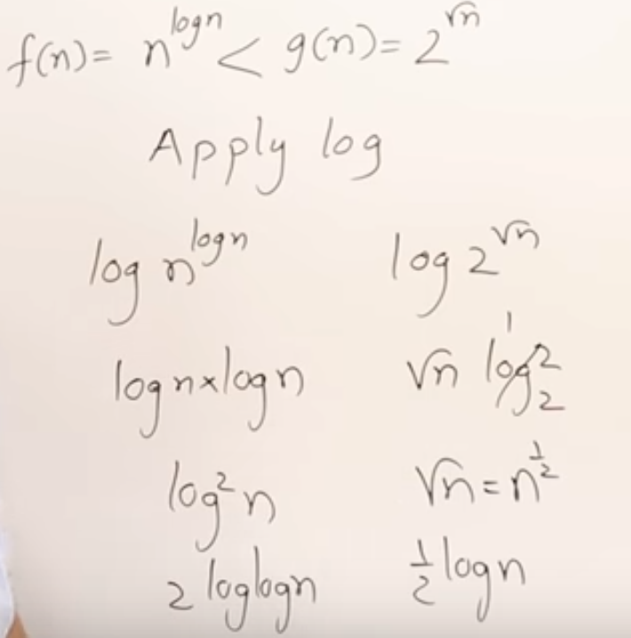

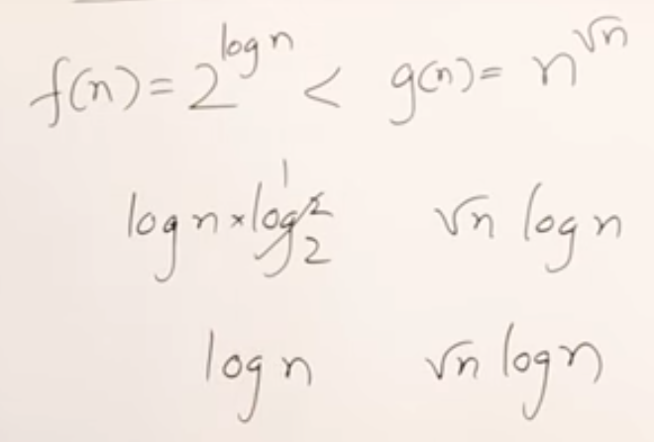

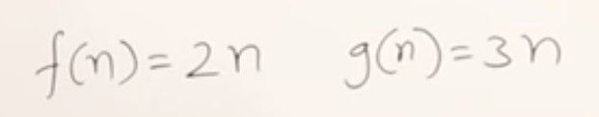

* These are equal

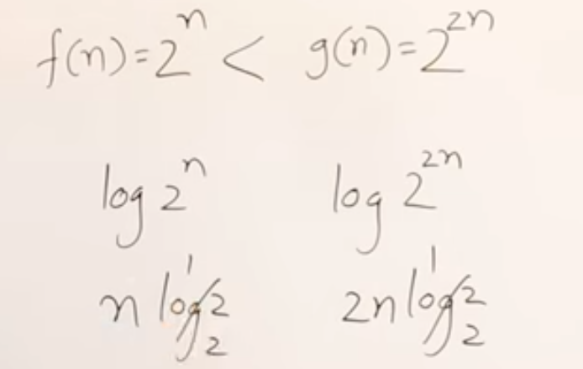

* After applying the log based on the result, we will say 2^2n is greater.
* Don’t ignore the coefficients after applying the log.

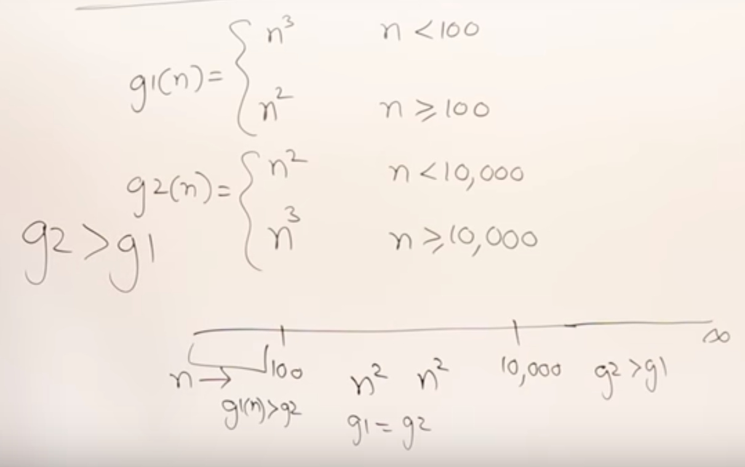

* We will always consider n for large values.

# 1.11 Best Worst and Average Case Analysis

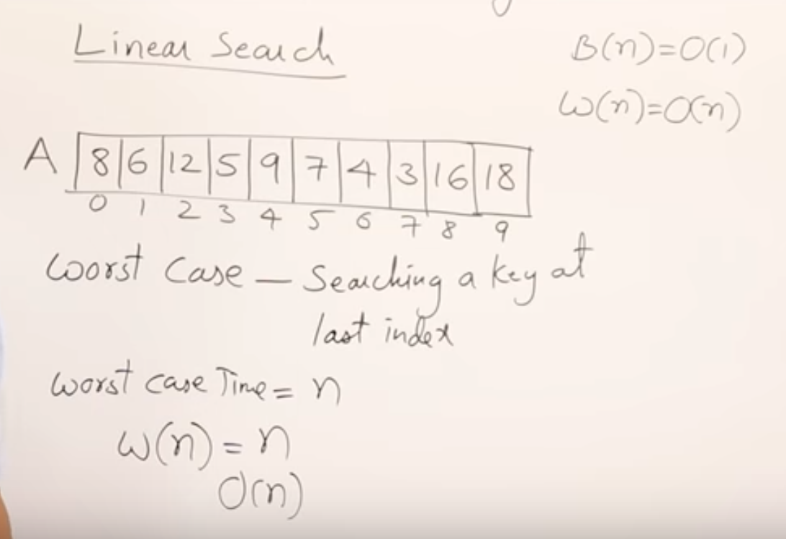

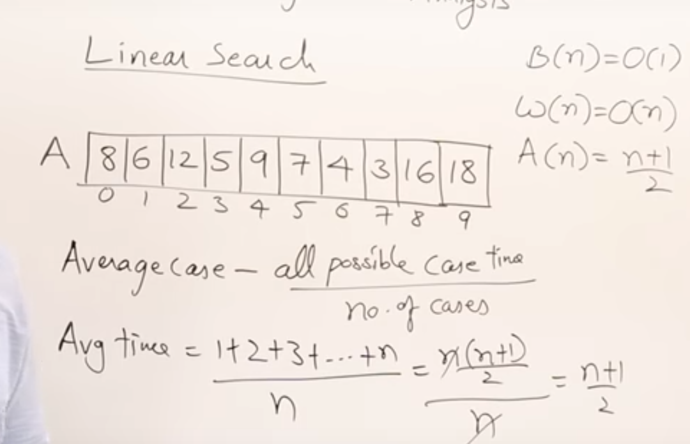

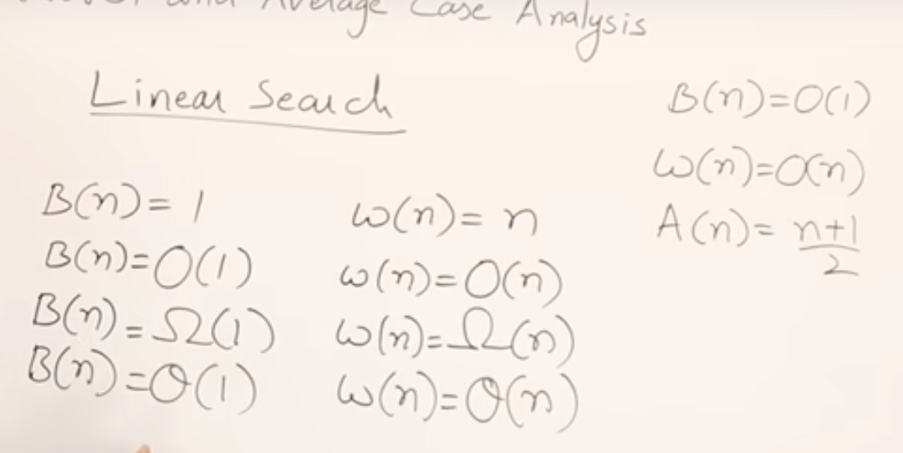

We can mention best average and worst cases in any notations.

There is no such thing like O (big o) is for worst

That is for avg ..etc

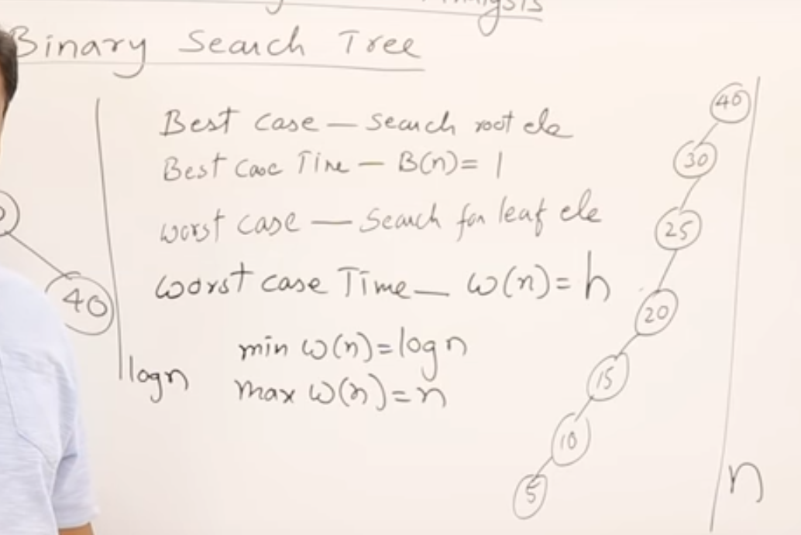

Worst case time log n when tree is organised well

Worst case is **n** when tree is depth in this situation, we will take max so worst case for binary search I s **n**

2 Divide And Conquer

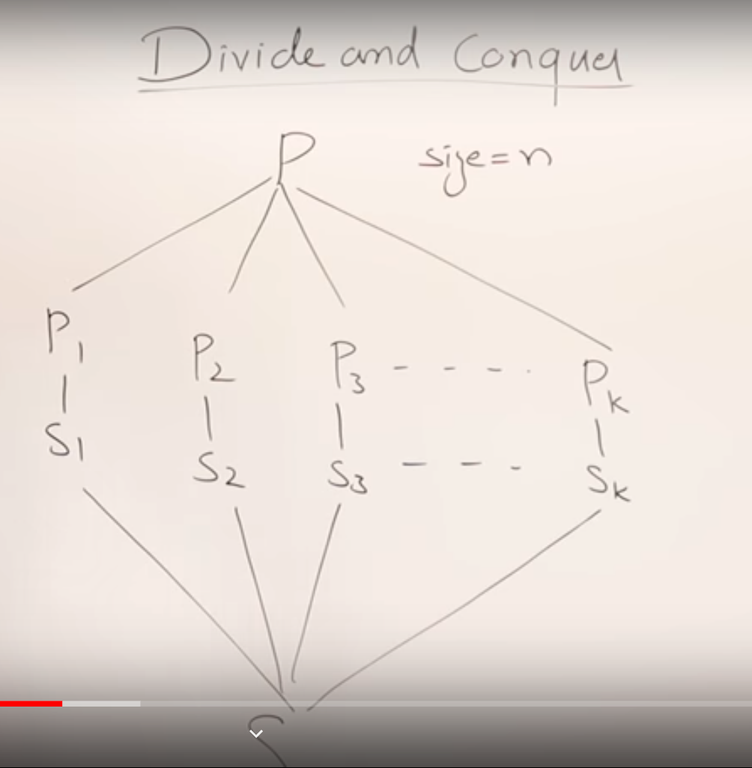

Divide and conquer is a problem solving strategy to solve the problem three is no specific formula for it

Divide the problem into small sub problems if the dived problem is also big divide further

All sub problem should the same task.

Solve all small problems and combine all solution into one solution to main problem

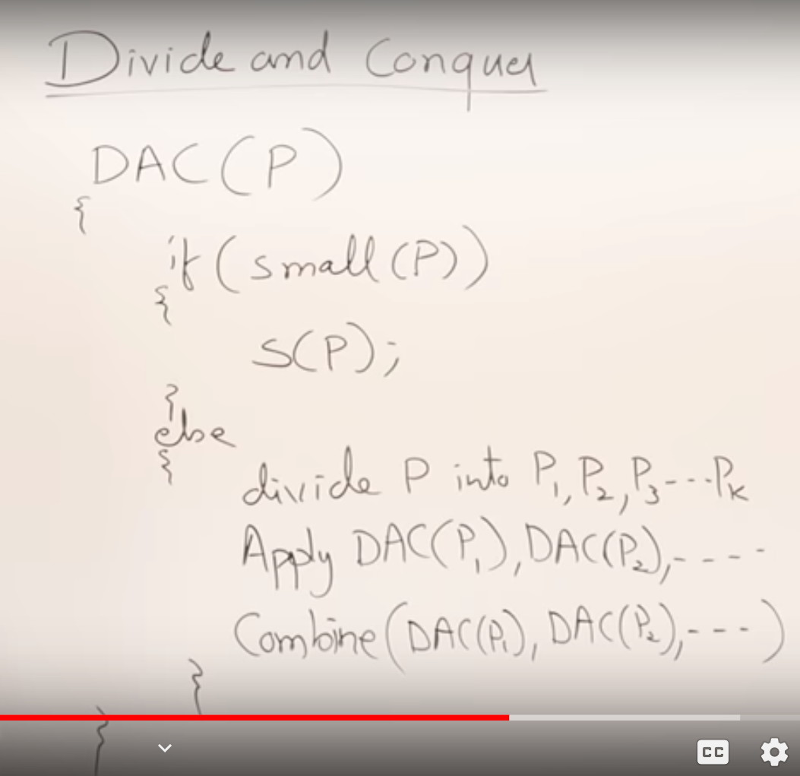

Divide and conquer is recursive

2.1.1 Recurrence Relation (T(n)= T(n-1) + 1) #1

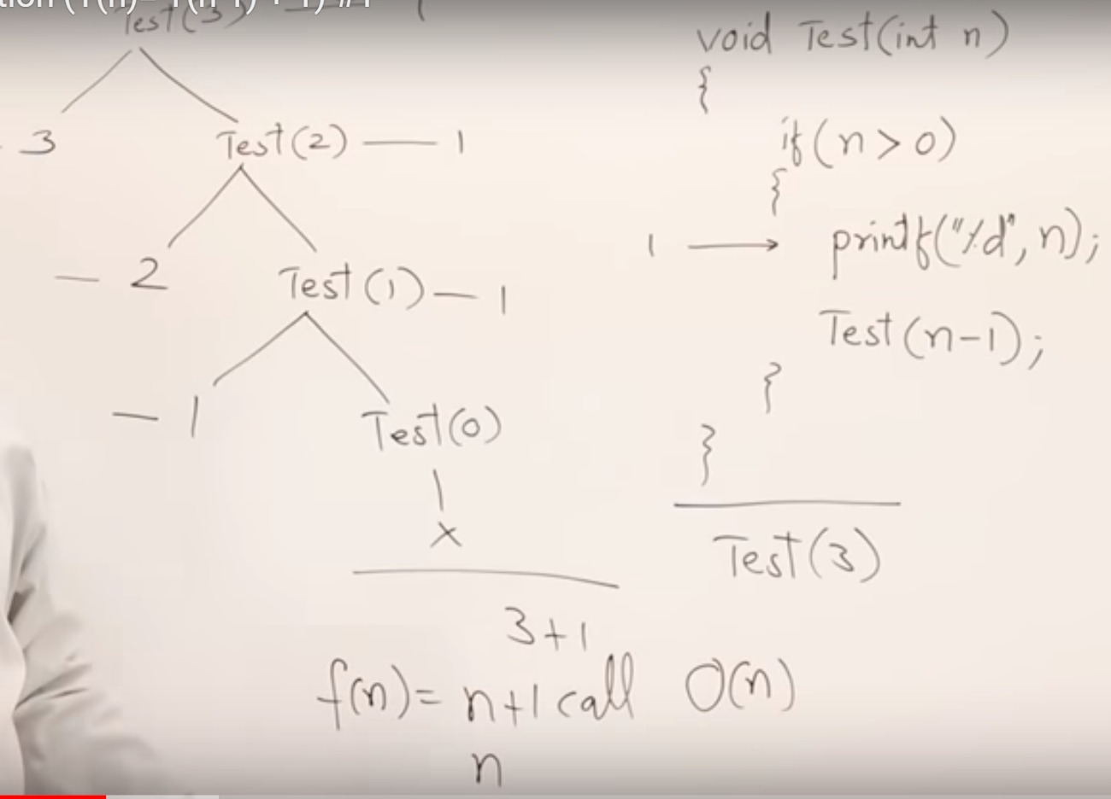

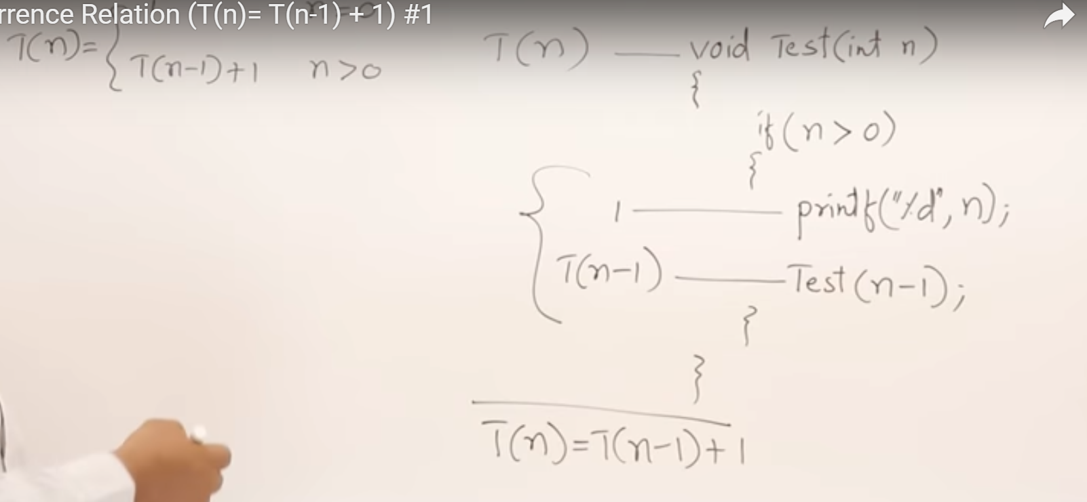

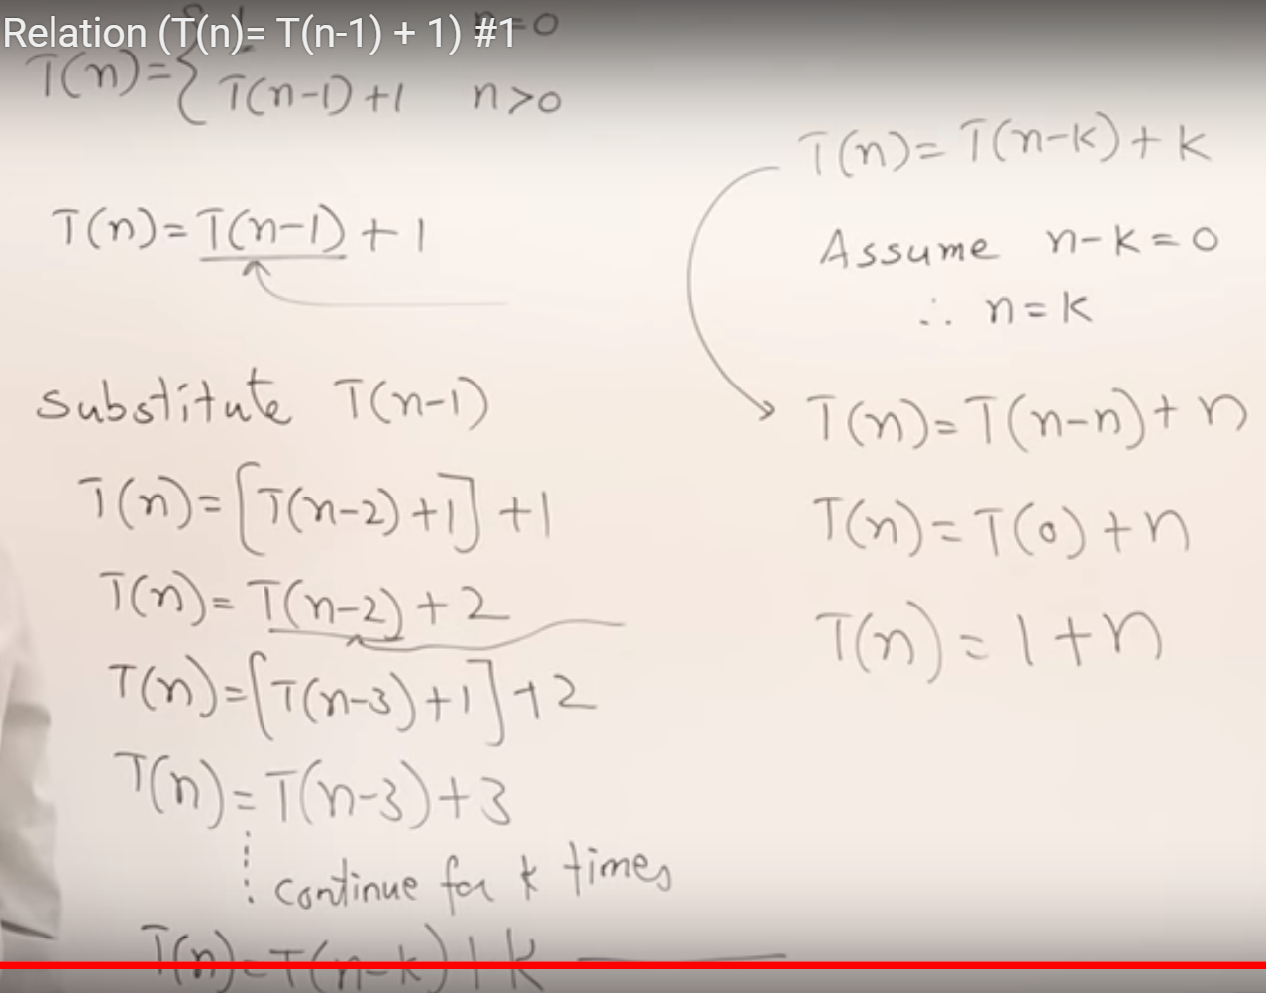

2.1.2 Recurrence Relation (T(n)= T(n-1) + n) #2

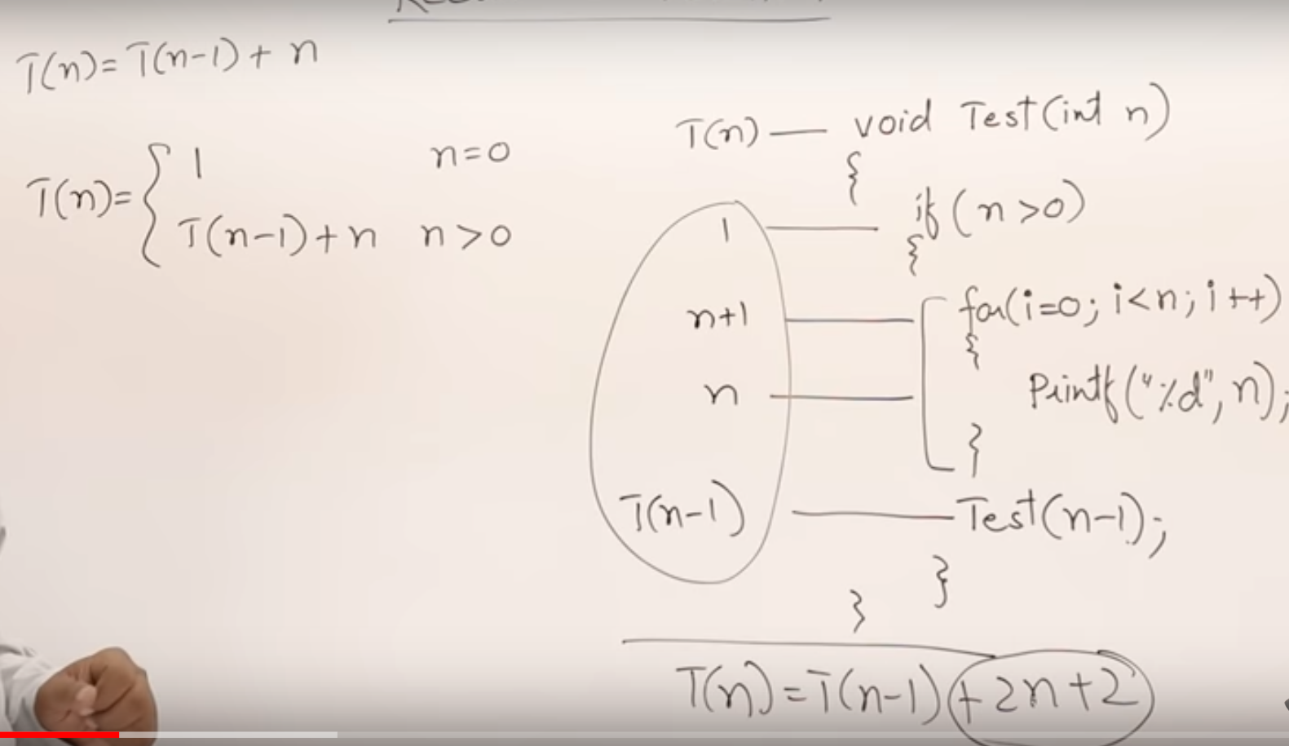

For 2n+2 we taken as **n** because we take asymptotically.

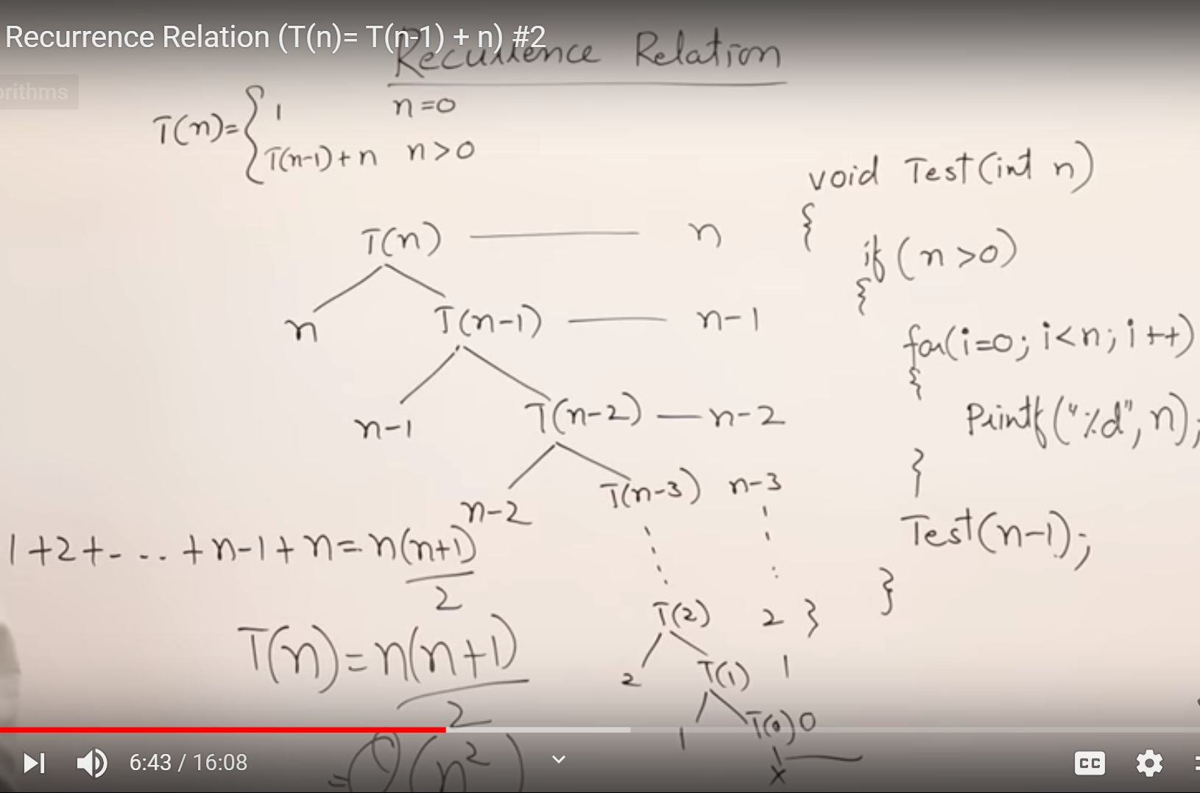

Recurrence tree method

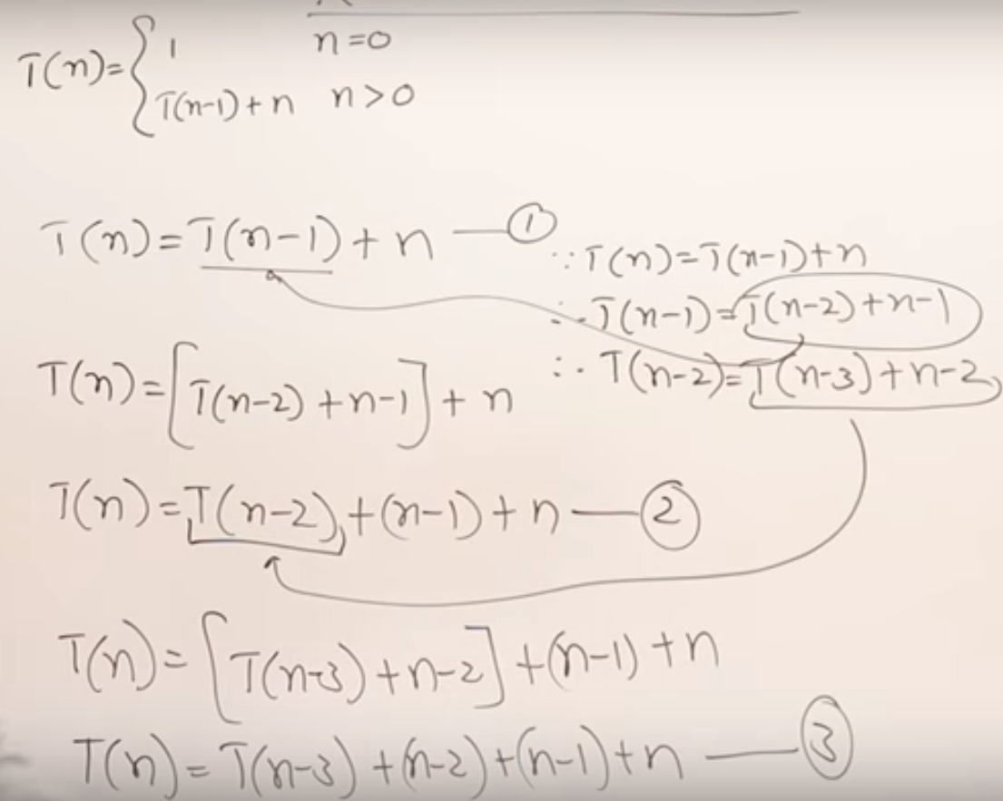

Substitution method

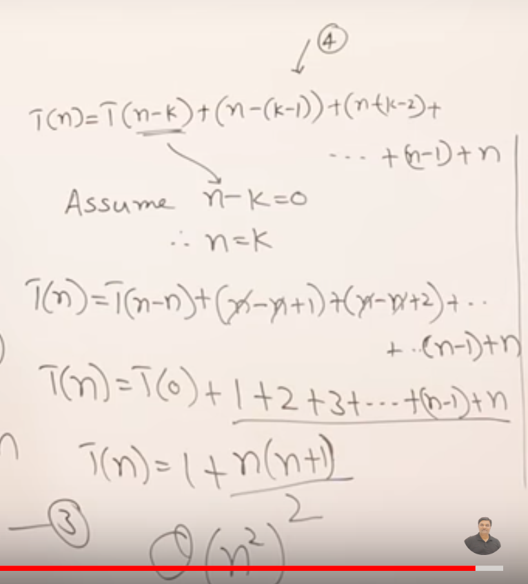

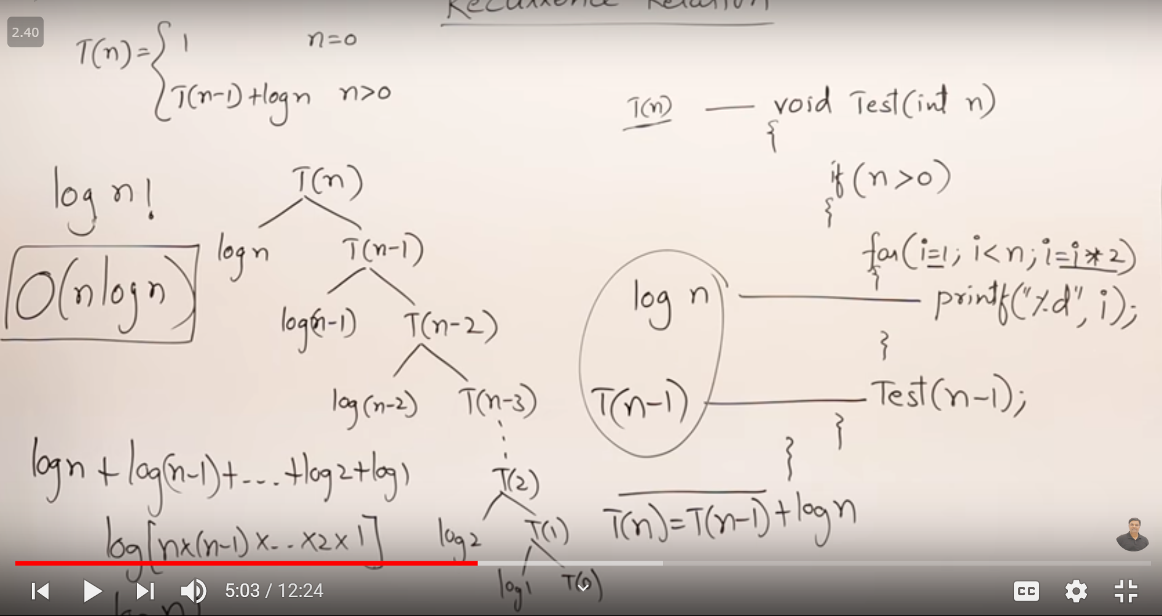

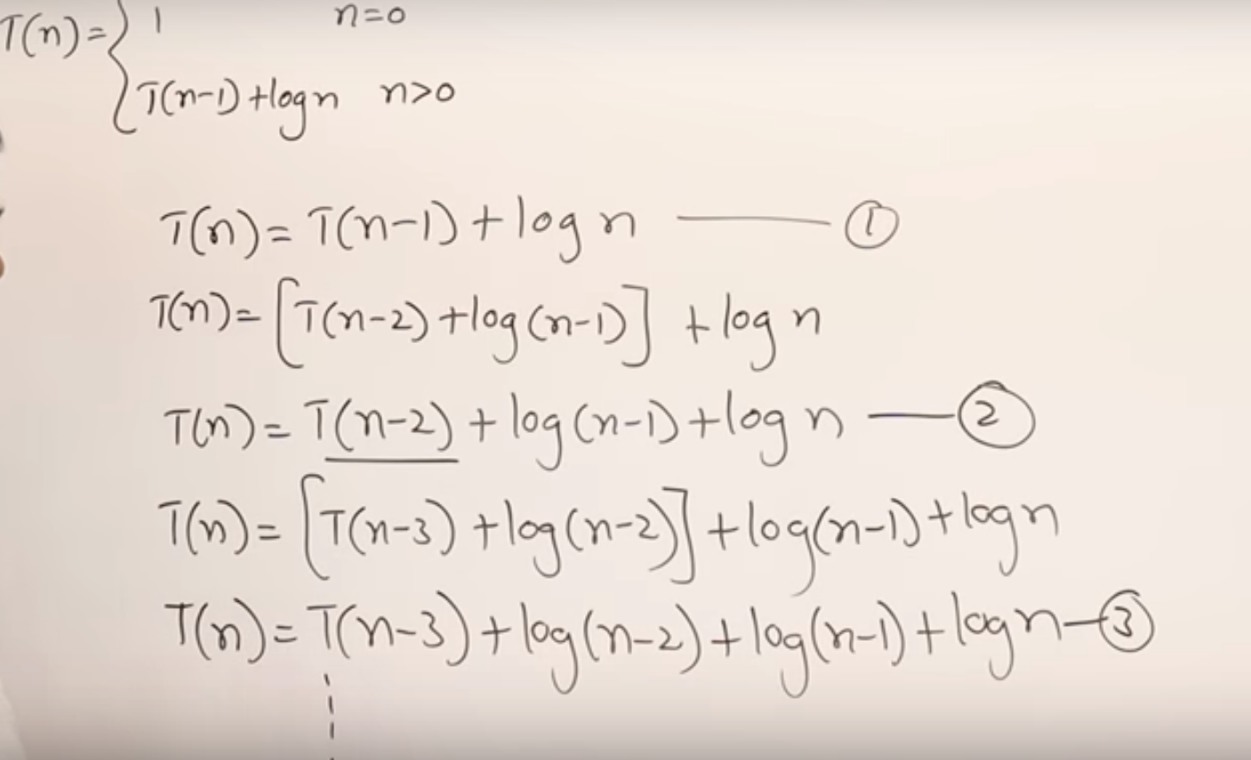

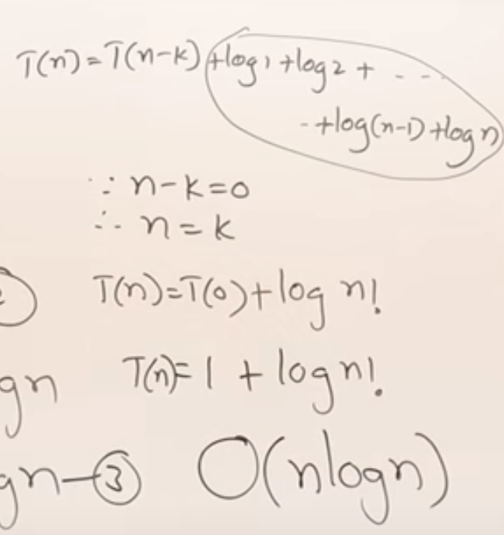

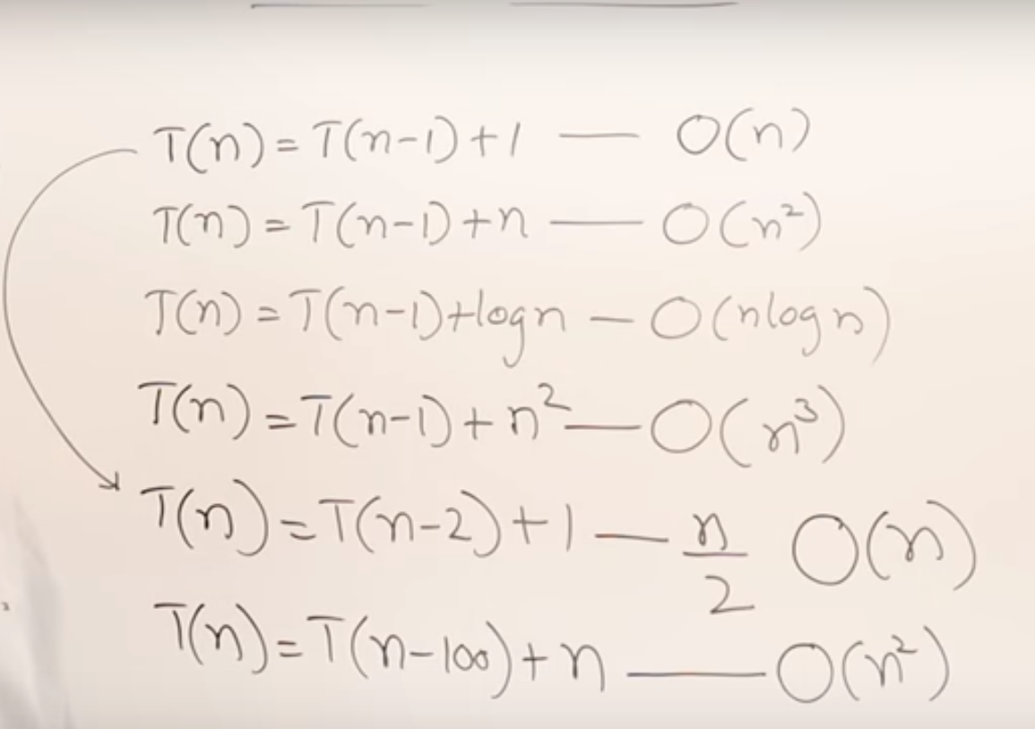

2.1.4 Recurrence Relation T(n)=2 T(n-1)+1 #4

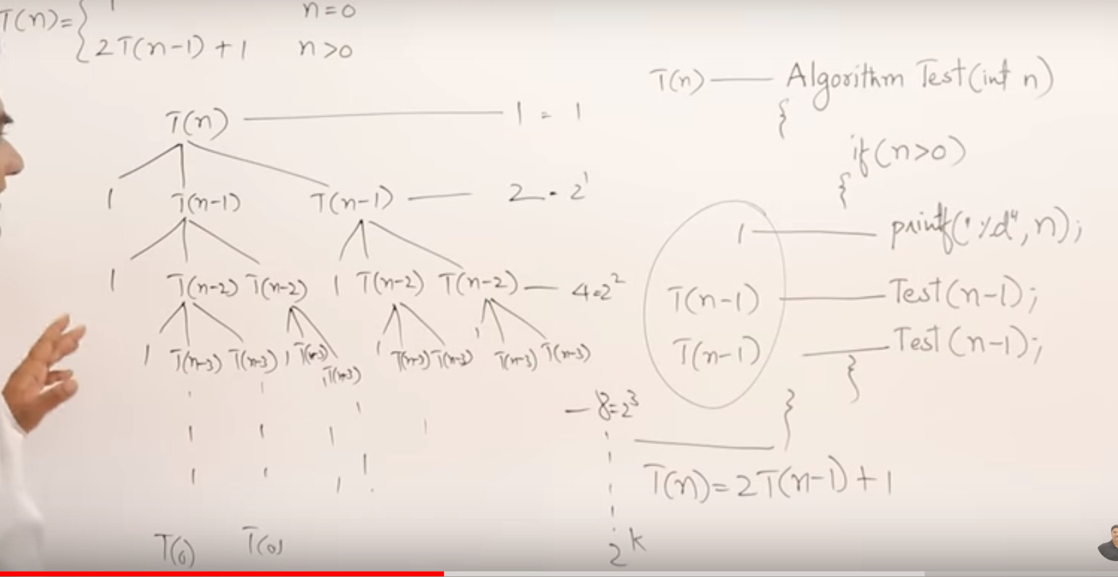

Recurrence tree method

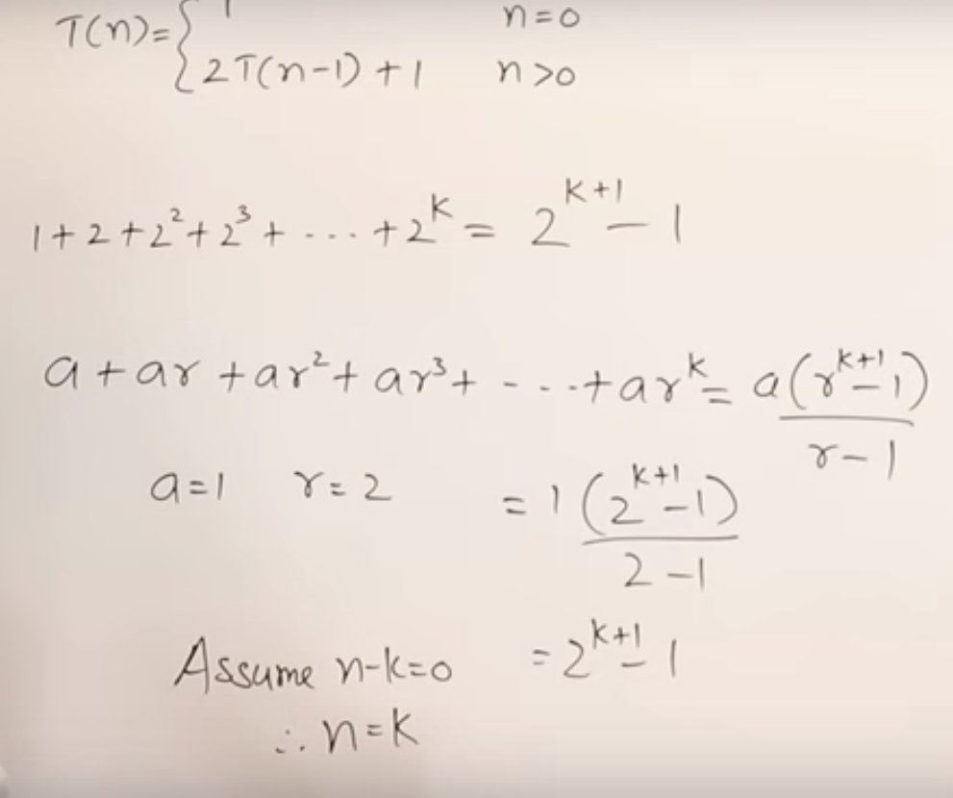

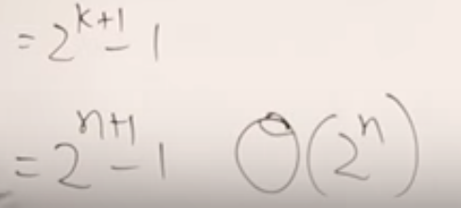

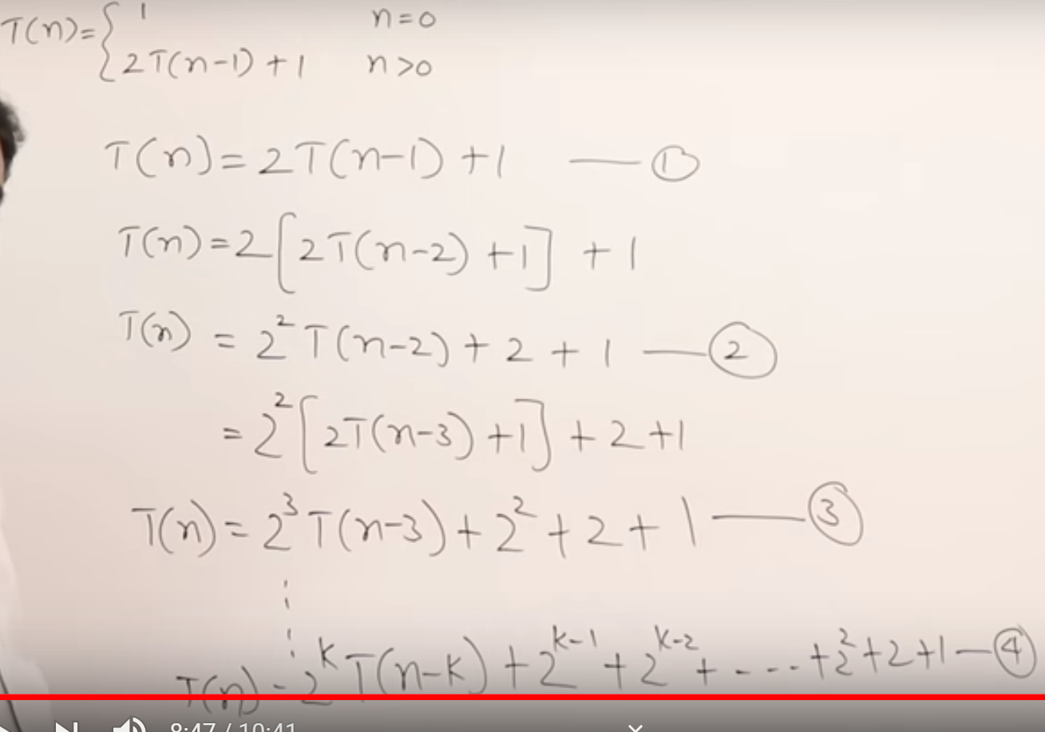

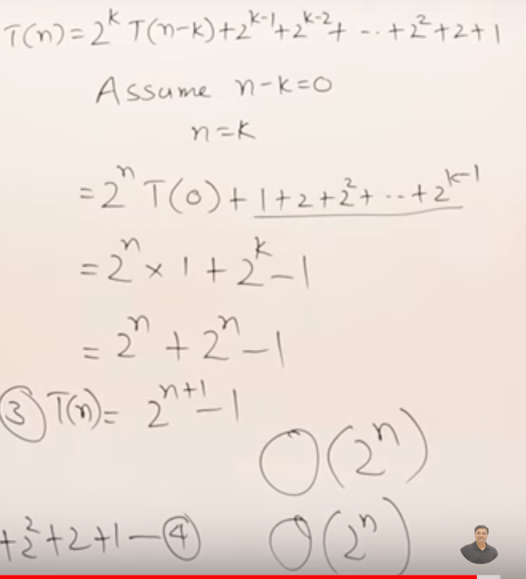

2.2 Masters Theorem Decreasing Function

